Table of Contents
Array Problem 2
Linked ListProblem 14
Catergory A 14
Category B 30
Catergory C 40
GRAPH Problem 48
Tree Problem 57
Part A 57
Part B 67
Part -C 76
Stack Problem 84
Queue Problem 105
Recursion Problem 114

Array Problem
Problem 1
Write a C program to insert an element in an array. Consider the Linear array NAME
[8] = {Adam, Clark, Evans, Gupta, Jones, Lane, Pace, Smith}.Which is sorted
alphabetically. Your task is to write C code for the followings:
I. Find NAME[2], NAME[4], NAME[7]
II. Insert Davis into the given array
III. Delete the element Gupta from the given array.
#include <stdio.h>
#include <string.h>
#define MAX_NAME_LENGTH 20
#define ARRAY_SIZE 8
void print_array(const char names[][MAX_NAME_LENGTH], int size)
{
printf("[");
for (int i = 0; i < size; i++) {
if (i > 0){
printf(", ");
}
printf("%s", names[i]);
}
printf("]\n");
}
int find_element_index(const char names[][MAX_NAME_LENGTH], int size,
const char *element)
{
for (int i = 0; i < size; i++)
{
if (strcmp(names[i], element) == 0)
{
return i;
}
}
return -1;
}
int insert_element(char names[][MAX_NAME_LENGTH], int size,
const char *element, int position)
{
if (size >= ARRAY_SIZE)
{
printf("Error: Array is full.\n");
return -1;
}
if (position < 0 || position > size)
{
printf("Error: Invalid position.\n");
return -1;
}
for (int i = size; i > position; i--)
{
strcpy(names[i], names[i - 1]);
}
strcpy(names[position], element);
return 1;
}
int delete_element(char names[][MAX_NAME_LENGTH], int size, const char *element)
{
int index = find_element_index(names, size, element);
if (index == -1)
{
printf("Error: Element not found.\n");
return -1;
}
for (int i = index; i < size - 1; i++)
{
strcpy(names[i], names[i + 1]);
}
return 1;
}
int main()
{
char names[][MAX_NAME_LENGTH] = {"Adam", "Clark", "Evans", "Gupta", "Jones",
"Lane", "Pace", "Smith"};
// Find specific elements
printf("NAME[2]: %s\n", names[2]);
printf("NAME[4]: %s\n", names[4]);
printf("NAME[7]: %s\n", names[7]);
// Insert element "Davis" into the Array
insert_element(names, ARRAY_SIZE, "Davis", 3);
printf("Array after inserting Davis:\n");
print_array(names, ARRAY_SIZE);
// Delete element "Gupta"
delete_element(names, ARRAY_SIZE, "Gupta");
printf("Array after deleting Gupta:\n");
print_array(names, ARRAY_SIZE);
return 0;
}
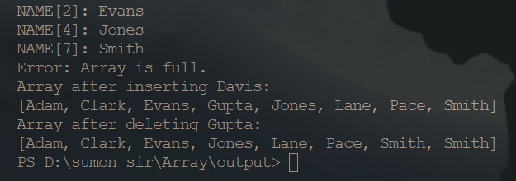
Problem 2
Write a C program to delete an element from an array at specified position
#include <stdio.h>
#define MAX_SIZE 100
int main()
{
int arr[MAX_SIZE];
int i, size, pos;
printf("Enter size of the array : ");
scanf("%d", &size);
printf("Enter elements in array : ");
for (i = 0; i < size; i++)
{
scanf("%d", &arr[i]);
}
printf("Enter the element position to delete : ");
scanf("%d", &pos);
if (pos < 0 || pos > size)
{
printf("Invalid position! Please enter position between 1 to %d", size);
}
else
{
for (i = pos - 1; i < size - 1; i++)
{
arr[i] = arr[i + 1];
}
size--;
printf("\nElements of array after delete are : ");
for (i = 0; i < size; i++)
{
printf("%d ", arr[i]);
}
}
return 0;
}
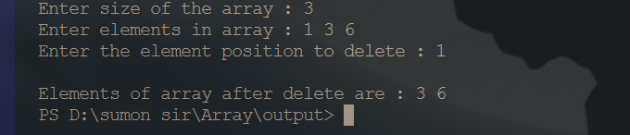
Problem 3
Write a C program to count frequency of each element in an array.
#include <stdio.h>
int main()
{
int arr[100], freq[100];
int size, i, j, count;

printf("Enter size of array: ");
scanf("%d", &size);
printf("Enter elements in array: ");
for(i=0; i<size; i++)
{
scanf("%d", &arr[i]);
freq[i] = -1;
}
for(i=0; i<size; i++)
{
count = 1;
for(j=i+1; j<size; j++)
{
if(arr[i]==arr[j])
{
count++;
freq[j] = 0;
}
}
if(freq[i] != 0)
{
freq[i] = count;
}
}
printf("\nFrequency of all elements of array : \n");
for(i=0; i<size; i++)
{
if(freq[i] != 0)
{
printf("%d occurs %d times\n", arr[i], freq[i]);
}
}
return 0;
}
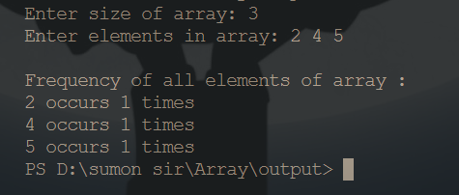
Problem 4
Write a C program to print all unique elements in the array
#include <stdio.h>
#define MAX_SIZE 100
int main()
{
int arr[MAX_SIZE], freq[MAX_SIZE];
int size, i, j, count;
printf("Enter size of array: ");
scanf("%d", &size);
printf("Enter elements in array: ");
for(i=0; i<size; i++)
{
scanf("%d", &arr[i]);
freq[i] = -1;
}
for(i=0; i<size; i++)
{
count = 1;
for(j=i+1; j<size; j++)
{
if(arr[i] == arr[j])
{
count++;
freq[j] = 0;
}
}
if(freq[i] != 0)
{
freq[i] = count;
}
}
printf("\nUnique elements in the array are: ");
for(i=0; i<size; i++)
{
if(freq[i] == 1)
{
printf("%d ", arr[i]);
}
}
return 0;
}
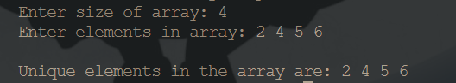
Problem 5
Write a C program to count total number of duplicate elements in an array
#include <stdio.h>
#define MAX_SIZE 100
int main()
{
int arr[MAX_SIZE];
int i, j, size, count = 0;

printf("Enter size of the array : ");
scanf("%d", &size);
printf("Enter elements in array : ");
for (i = 0; i < size; i++)
{
scanf("%d", &arr[i]);
}
for (i = 0; i < size; i++)
{
for (j = i + 1; j < size; j++)
{
if (arr[i] == arr[j])
{
count++;
break;
}
}
}

printf("\nTotal number of duplicate elements found in array = %d", count);

return 0;
}
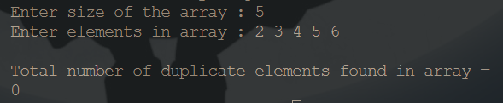
Problem 6
Write a C program to delete all duplicate elements from an array.
#include <stdio.h>
#define MAX_SIZE 100
int main()
{
int arr[MAX_SIZE];
int size;
int i, j, k;
printf("Enter size of the array : ");
scanf("%d", &size);
printf("Enter elements in array : ");
for(i=0; i<size; i++)
{
scanf("%d", &arr[i]);
}
for(i=0; i<size; i++)
{
for(j=i+1; j<size; j++)
{
if(arr[i] == arr[j])
{

for(k=j; k < size - 1; k++)
{
arr[k] = arr[k + 1];
}
size--;

j--;
}
}
}
printf("\nArray elements after deleting duplicates : ");
for(i=0; i<size; i++)
{
printf("%d ", arr[i]);
}
return 0;
}
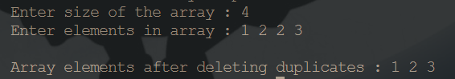
Problem 07
Write a C program to merge two array to third array.
#include <stdio.h>
#define MAX_SIZE 100
int main(){
int arr1[MAX_SIZE], arr2[MAX_SIZE], mergeArray[MAX_SIZE * 2];
int size1, size2, mergeSize;
int index1, index2, mergeIndex;
int i;
printf("Enter the size of first array : ");
scanf("%d", &size1);
printf("Enter elements in first array : ");
for(i=0; i<size1; i++)
{
scanf("%d", &arr1[i]);
}
printf("\nEnter the size of second array : ");
scanf("%d", &size2);
printf("Enter elements in second array : ");
for(i=0; i<size2; i++)
{
scanf("%d", &arr2[i]);
}
mergeSize = size1 + size2;
index1 = 0;
index2 = 0;
for(mergeIndex=0; mergeIndex < mergeSize; mergeIndex++)
{
if(index1 >= size1 || index2 >= size2)
{
break;
}
if(arr1[index1] < arr2[index2])
{
mergeArray[mergeIndex] = arr1[index1];
index1++;
}
else
{
mergeArray[mergeIndex] = arr2[index2];
index2++;
}
}
while(index1 < size1)
{
mergeArray[mergeIndex] = arr1[index1];
mergeIndex++;
index1++;
}
while(index2 < size2)
{
mergeArray[mergeIndex] = arr2[index2];
mergeIndex++;
index2++;
}
printf("\nArray merged in ascending order : ");
for(i=0; i<mergeSize; i++)
{
printf("%d ", mergeArray[i]);
}
return 0;
}
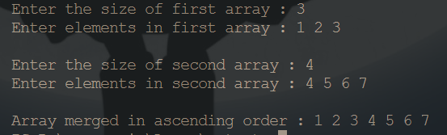
Problem 08
Write a C program to find reverse of an array.
#include <stdio.h>
#define MAX_SIZE 100
int main()
{
int arr[MAX_SIZE];
int size, i;
printf("Enter size of the array: ");
scanf("%d", &size);
printf("Enter elements in array: ");
for (i = 0; i < size; i++)
{
scanf("%d", &arr[i]);
}
printf("\nArray in reverse order: ");
for (i = size - 1; i >= 0; i--)
{
printf("%d\t", arr[i]);
}

return 0;
}
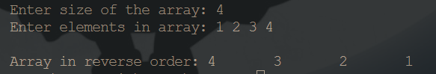
Problem 09
Write a C program to put even and odd elements of array in two separate array.
#include <stdio.h>
#define MAX_SIZE 1000
void printArray(int arr[], int len);
int main()
{
int arr[MAX_SIZE];
int even[MAX_SIZE], odd[MAX_SIZE];
int evenCount, oddCount;
int i, size;
printf("Enter size of the array: ");
scanf("%d", &size);
printf("Enter elements in the array: ");
for (i = 0; i < size; i++)
{
scanf("%d", &arr[i]);
}
evenCount = 0;
oddCount = 0;
for (i = 0; i < size; i++)
{
if (arr[i] & 1)
{
odd[oddCount] = arr[i];
oddCount++;
}
else
{
even[evenCount] = arr[i];
evenCount++;
}
}
printf("\nElements of even array: \n");
printArray(even, evenCount);

printf("\nElements of odd array: \n");
printArray(odd, oddCount);
return 0;
}
void printArray(int arr[], int len)
{
int i;
printf("Elements in the array: ");
for (i = 0; i < len; i++)
{
printf("%d ", arr[i]);
}
printf("\n");
}
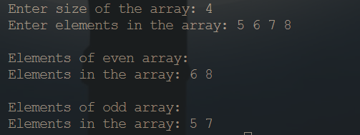
Problem 10
Write a C program to search an element in an array.
#include <stdio.h>
#define MAX_SIZE 100
int main()
{
int arr[MAX_SIZE];
int size, i, toSearch, found;
printf("Enter size of array: ");
scanf("%d", &size);
printf("Enter elements in array: ");
for(i=0; i<size; i++)
{
scanf("%d", &arr[i]);
}

printf("\nEnter element to search: ");
scanf("%d", &toSearch);
found = 0;
for(i=0; i<size; i++)
{
if(arr[i] == toSearch)
{
found = 1;
break;
}
}
if(found == 1)
{
printf("\n%d is found at position %d", toSearch, i + 1);
}
else
{
printf("\n%d is not found in the array", toSearch);
}
return 0;
}
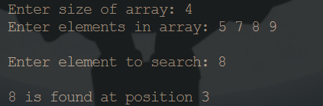
Problem 11
Write a C program to sort array elements in ascending or descending order.
#include <stdio.h>
#define MAX_SIZE 100
int main()
{
int arr[MAX_SIZE];
int size;
int i, j, temp;
printf("Enter size of array: ");
scanf("%d", &size);
printf("Enter elements in array: ");
for(i=0; i<size; i++)
{
scanf("%d", &arr[i]);
}
for(i=0; i<size; i++)
{
for(j=i+1; j<size; j++)
{
if(arr[i] > arr[j])
{
temp = arr[i];
arr[i] = arr[j];
arr[j] = temp;
}
}
}
printf("\nElements of array in ascending order: ");
for(i=0; i<size; i++)
{
printf("%d ", arr[i]);
}
return 0;
}
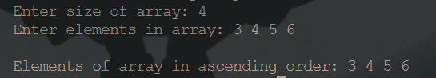
Problem 12
Write a C program to sort even and odd elements of array separately
#include <stdio.h>
void bubbleSort(int arr[], int size) {
for (int i = 0; i < size - 1; i++) {
for (int j = 0; j < size - i - 1; j++) {
if (arr[j] > arr[j + 1]) {
int temp = arr[j];
arr[j] = arr[j + 1];
arr[j + 1] = temp;
}
}
}
}

void sortEvenOdd(int arr[], int size) {
int evenArr[size], oddArr[size];
int evenCount = 0, oddCount = 0;

for (int i = 0; i < size; i++) {
if (arr[i] % 2 == 0) {
evenArr[evenCount++] = arr[i];
} else {
oddArr[oddCount++] = arr[i];
}
}
bubbleSort(evenArr, evenCount);
bubbleSort(oddArr, oddCount);
int index = 0;
for (int i = 0; i < evenCount; i++) {
arr[index++] = evenArr[i];
}
for (int i = 0; i < oddCount; i++) {
arr[index++] = oddArr[i];
}
}

int main() {
int size;
printf("Enter the size of the array: ");
scanf("%d", &size);
int arr[size];
printf("Enter elements of the array: ");
for (int i = 0; i < size; i++) {
scanf("%d", &arr[i]);
}
sortEvenOdd(arr, size);
printf("Sorted array with even and odd elements separated: ");
for (int i = 0; i < size; i++) {
printf("%d ", arr[i]);
}

return 0;
}
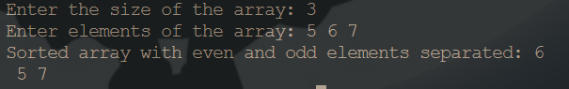
Problem 13
Write a C program to left rotate an array.
#include <stdio.h>
void left_rotate_array(int arr[], int size, int rotations) {
int temp_arr[size];
for (int i = 0; i < size; ++i) {
temp_arr[(i + rotations) % size] = arr[i];
}
for (int i = 0; i < size; ++i) {
arr[i] = temp_arr[i];
}
}
int main() {
int size, rotations;
printf("Enter the size of the array: ");
scanf("%d", &size);
int arr[size];
printf("Enter elements of the array: ");
for (int i = 0; i < size; ++i) {
scanf("%d", &arr[i]);
}
printf("Enter the number of rotations: ");
scanf("%d", &rotations);
left_rotate_array(arr, size, rotations);
printf("Rotated array: ");
for (int i = 0; i < size; ++i) {
printf("%d ", arr[i]);
}
printf("\n");
return 0;
}
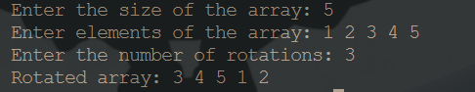

Linked ListProblem

Catergory A
Problem 1
Singular Linked List Double Linked list and Circular Linked List.
Write a code for traversing a linked list.
#include <stdio.h>
#include <stdlib.h>
struct Node
{
int data;
struct Node *next;
};
void linkedlistTraversal(struct Node *ptr)
{
while (ptr != NULL)
{
printf("Element: %d\n", ptr->data);
ptr = ptr->next;
}
}
int main()
{
struct Node *head = NULL;
struct Node *last = NULL;
int n, data;
printf("Enter the data for nodes (enter -1 to stop):\n");
while (1)
{
printf("Enter data: ");
scanf("%d", &data);
if (data == -1)
{
break;
}
struct Node *newNode = (struct Node *)malloc(sizeof(struct Node));
newNode->data = data;
newNode->next = NULL;
if (head == NULL)
{
head = newNode;
last = newNode;
}
else
{
last->next = newNode;
last = newNode;
}
}
printf("Linked List:\n");
linkedlistTraversal(head);
return 0;} 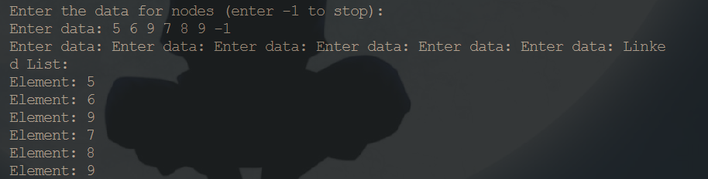
Problem 2
Write a code for counting number of nodes in a linked list.
#include <stdio.h>
#include <stdlib.h>
struct Node
{
int data;
struct Node *next;
};
struct Node *insertNode(struct Node *head, int data)
{
struct Node *newNode = (struct Node *)malloc(sizeof(struct Node));
newNode->data = data;
newNode->next = NULL;

if (head == NULL)
{
head = newNode;
}
else
{
struct Node *temp = head;
while (temp->next != NULL)
{
temp = temp->next;
}
temp->next = newNode;
}
return head;
}
int countNodes(struct Node *head)
{
int count = 0;
struct Node *temp = head;

while (temp != NULL)
{
count++;
temp = temp->next;
}
return count;
}
void displayList(struct Node *head)
{
struct Node *temp = head;
while (temp != NULL)
{
printf("%d -> ", temp->data);
temp = temp->next;
}
printf("NULL\n");
}

int main()
{
struct Node *head = NULL;
int val;

printf("Enter the values for the linked list (enter -1 to stop):\n");
while (1)
{
scanf("%d", &val);
if (val == -1)
break;
head = insertNode(head, val);
}
printf("Linked List: ");
displayList(head);
int nodeCount = countNodes(head);
printf("Number of nodes in the linked list: %d\n", nodeCount);
return 0;
}
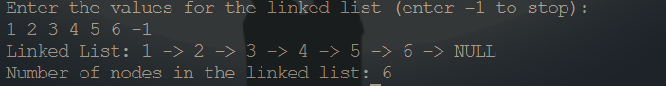
Problem 3
Write a code for inserting node in a linked list (initial, middle and last) position in the node.
#include <stdio.h>
#include <stdlib.h>
struct Node
{
int data;
struct Node *next;
};
void linkedlistTraversal(struct Node *ptr)
{
while (ptr != NULL)
{
printf("Element: %d\n", ptr->data);
ptr = ptr->next;
}
}
struct Node *insertAtFirst(struct Node *head, int data)
{
struct Node *ptr = (struct Node *)malloc(sizeof(struct Node));
ptr->data = data;
ptr->next = head;
return ptr;
}
struct Node *insertAtEnd(struct Node *head, int data)
{
struct Node *ptr = (struct Node *)malloc(sizeof(struct Node));
ptr->data = data;
ptr->next = NULL;

if (head == NULL)
{
return ptr;
}
struct Node *p = head;
while (p->next != NULL)
{
p = p->next;
}
p->next = ptr;
return head;
}
int main()
{
struct Node *head = NULL;
int n, data;
printf("Enter the number of nodes: ");
scanf("%d", &n);

for (int i = 1; i <= n; i++)
{
printf("Enter data for node %d: ", i);
scanf("%d", &data);
head = insertAtEnd(head, data);
}
printf("Linked List:\n");
linkedlistTraversal(head);
return 0;
}

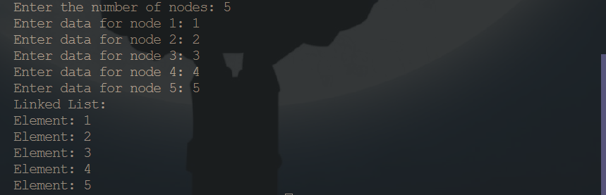
Problem 4
Write a code for searching an item for sorted and unsorted linked list.
#include <stdio.h>
#include <stdlib.h>

struct Node
{
int data;
struct Node *next;
};
void linkedlistTraversal(struct Node *ptr)
{
while (ptr != NULL)
{
printf("Element: %d\n", ptr->data);
ptr = ptr->next;
}
}
int searchElement(struct Node *head, int target)
{
struct Node *current = head;
int position = 1;
while (current != NULL)
{
if (current->data == target)
{
return position;
}
current = current->next;
position++;
}
return -1; // Element not found
}
int main()
{
struct Node *head = NULL;
struct Node *last = NULL;
int n, data;

printf("Enter the number of nodes: ");
scanf("%d", &n);
for (int i = 1; i <= n; i++)
{
printf("Enter data for node %d: ", i);
scanf("%d", &data);

struct Node *newNode = (struct Node *)malloc(sizeof(struct Node));
newNode->data = data;
newNode->next = NULL;
if (head == NULL)
{
head = newNode;
last = newNode;
}
else
{
last->next = newNode;
last = newNode;
}
}
printf("Linked List:\n");
linkedlistTraversal(head);

int targetElement;
printf("Enter the element to search: ");
scanf("%d", &targetElement);

int position = searchElement(head, targetElement);
if (position != -1)
{
printf("Element %d found at position %d\n", targetElement, position);
}
else
{
printf("Element %d not found in the list\n", targetElement);
}

return 0;
}
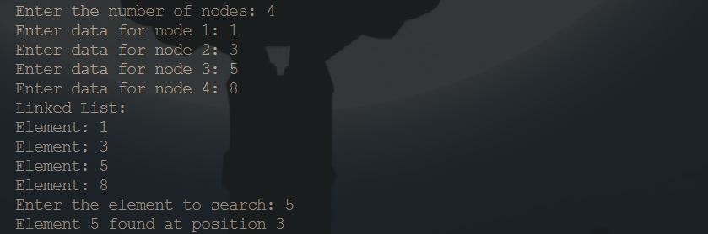
Problem 5
Write a code for deleting node in a linked list (initial, middle and last) position in the node
#include <stdio.h>
#include <stdlib.h>
struct Node
{
int data;
struct Node *next;
};
void linkedlistTraversal(struct Node *ptr)
{
while (ptr != NULL)
{
printf("Element: %d\n", ptr->data);
ptr = ptr->next;
}
}
struct Node *delatlast(struct Node *head)
{
struct Node *p = head;
struct Node *q = head->next;
while (q->next != NULL)
{
p = p->next;
q = q->next;
}
p->next = q->next;
free(q);
return head;
}
/*
struct Node *deleteAtFirst(struct Node *head)
{
if (head == NULL)
{
printf("List is empty, nothing to delete.\n");
return NULL;
}
struct Node *ptr = head;
head = head->next;
free(ptr);
return head;
}
*/
/*
struct Node *indexdelete(struct Node *head, int index)
{
struct Node *p = head;

for (int i = 0; i < index - 1; i++)
{
p = p->next;

}
struct Node* deleteNode=p->next;
p->next = p->next->next;
free(deleteNode);
return head;
}
*/
int main()
{
struct Node *head = NULL;
struct Node *last = NULL;
int n, data;
printf("Enter the number of nodes: ");
scanf("%d", &n);

for (int i = 1; i <= n; i++)
{
printf("Enter data for node %d: ", i);
scanf("%d", &data);
struct Node *newNode = (struct Node *)malloc(sizeof(struct Node));
newNode->data = data;
newNode->next = NULL;
if (head == NULL)
{
head = newNode;
last = newNode;
}
else
{
last->next = newNode;
last = newNode;
}
}
/* delete at first
printf("Linked List:\n");
linkedlistTraversal(head);

head = deleteAtFirst(head);
printf("New Linked List after deleting first element:\n");
linkedlistTraversal(head);
*/
/* delete at index
int index;
scanf("%d", &index);
head = indexdelete(head,index);
linkedlistTraversal(head);
*/
head = delatlast(head);
linkedlistTraversal(head);
return 0;
}
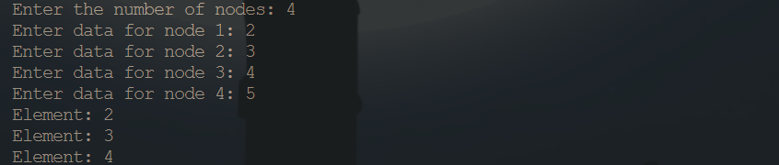
Problem 6
Write a code to display the elements in a reverse order in a linked list
#include <stdio.h>
#include <stdlib.h>
struct Node
{
int data;
struct Node *next;
};
struct Node *insertNode(struct Node *head, int data)
{
struct Node *newNode = (struct Node *)malloc(sizeof(struct Node));
newNode->data = data;
newNode->next = NULL;

if (head == NULL)
{
head = newNode;
}
else
{
struct Node *temp = head;
while (temp->next != NULL)
{
temp = temp->next;
}
temp->next = newNode;
}

return head;
}
struct Node *reverseList(struct Node *head)
{
struct Node *prev = NULL;
struct Node *current = head;
struct Node *next = NULL;

while (current != NULL)
{
next = current->next;
current->next = prev;
prev = current;
current = next;
}

return prev;
}

void displayList(struct Node *head)
{
struct Node *temp = head;
while (temp != NULL)
{
printf("%d -> ", temp->data);
temp = temp->next;
}
printf("NULL\n");
}
int main()
{
struct Node *head = NULL;
int val;
printf("Enter the values for the linked list (enter -1 to stop):\n");
while (1)
{
scanf("%d", &val);
if (val == -1)
break;
head = insertNode(head, val);
}
printf("Original Linked List: ");
displayList(head);
head = reverseList(head);
printf("Reversed Linked List: ");
displayList(head);
return 0;
}
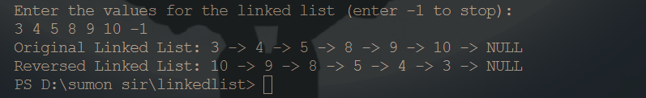
Problem 7
Find nth node from the end of linked list
#include <stdio.h>
#include <stdlib.h>
struct Node {
int data;
struct Node *next;
};
struct Node *insertNode(struct Node *head, int data) {
struct Node *newNode = (struct Node *)malloc(sizeof(struct Node));
newNode->data = data;
newNode->next = NULL;
if (head == NULL) {
head = newNode;
} else {
struct Node *temp = head;
while (temp->next != NULL) {
temp = temp->next;
}
temp->next = newNode;
}

return head;
}
struct Node *nthNodeFromEnd(struct Node *head, int n) {
if (head == NULL || n <= 0) {
printf("Invalid input\n");
return NULL;
}
struct Node *first = head;
struct Node *second = head;
for (int i = 0; i < n; ++i) {
if (first == NULL) {
printf("Invalid value of n\n");
return NULL;
}
first = first->next;
}
while (first != NULL) {
first = first->next;
second = second->next;
}
return second;
}
void displayList(struct Node *head) {
struct Node *temp = head;
while (temp != NULL) {
printf("%d -> ", temp->data);
temp = temp->next;
}
printf("NULL\n");
}

int main() {
struct Node *head = NULL;
int val, n;
printf("Enter the values for the linked list (enter -1 to stop):\n");
while (1) {
scanf("%d", &val);
if (val == -1)
break;
head = insertNode(head, val);
}
printf("Original Linked List: ");
displayList(head);

printf("Enter the value of n: ");
scanf("%d", &n);
struct Node *result = nthNodeFromEnd(head, n);
if (result != NULL)
printf("The %dth node from the end is: %d\n", n, result->data);

return 0;
}
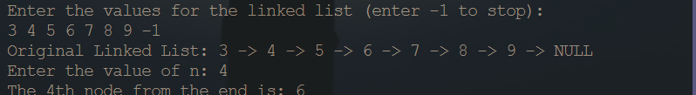
Problem 8
Move Last Element of Linked List to Front
#include <stdio.h>
#include <stdlib.h>

struct Node
{
int data;
struct Node *next;
};

void linkedlistTraversal(struct Node *ptr)
{
while (ptr != NULL)
{
printf("Element: %d\n", ptr->data);
ptr = ptr->next;
}
}
struct Node *moveLastToFront(struct Node *head)
{
if (head == NULL || head->next == NULL)
{
return head;
}
struct Node *secondLast = NULL;
struct Node *p = head;
while (p->next != NULL)
{
secondLast = p;
p = p->next;
}
secondLast->next = NULL;
p->next = head;
head = p;
return head;
}
int main()
{
struct Node *head = NULL;
struct Node *last = NULL;
int n, data;

printf("Enter the number of nodes: ");
scanf("%d", &n);

for (int i = 1; i <= n; i++)
{
printf("Enter data for node %d: ", i);
scanf("%d", &data);
struct Node *newNode = (struct Node *)malloc(sizeof(struct Node));
newNode->data = data;
newNode->next = NULL;

if (head == NULL)
{
head = newNode;
last = newNode;
}
else
{
last->next = newNode;
last = newNode;
}
}

printf("Linked List before moving last element to front:\n");
linkedlistTraversal(head);
head = moveLastToFront(head);
printf("Linked List after moving last element to front:\n");
linkedlistTraversal(head);
return 0;
}
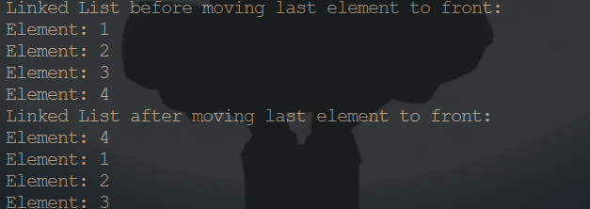
Problem 9
Move the first element of the linked list to the end
#include <stdio.h>
#include <stdlib.h>
struct Node
{
int data;
struct Node *next;
};
void linkedlistTraversal(struct Node *ptr)
{
while (ptr != NULL)
{
printf("Element: %d\n", ptr->data);
ptr = ptr->next;
}
}
struct Node *moveFirstToEnd(struct Node *head)
{
if (head == NULL || head->next == NULL)
{
return head;
}

struct Node *first = head;
struct Node *second = head->next;
struct Node *p = head;
while (p->next != NULL)
{
p = p->next;
}
p->next = first;
head = second;
first->next = NULL;
return head;
}

int main()
{
struct Node *head = NULL;
struct Node *last = NULL;
int n, data;

printf("Enter the number of nodes: ");
scanf("%d", &n);

for (int i = 1; i <= n; i++)
{
printf("Enter data for node %d: ", i);
scanf("%d", &data);
struct Node *newNode = (struct Node *)malloc(sizeof(struct Node));
newNode->data = data;
newNode->next = NULL;

if (head == NULL)
{
head = newNode;
last = newNode;
}
else
{
last->next = newNode;
last = newNode;
}
}

printf("Linked List before moving first element to end:\n");
linkedlistTraversal(head);
head = moveFirstToEnd(head);
printf("Linked List after moving first element to end:\n");
linkedlistTraversal(head);

return 0;
}
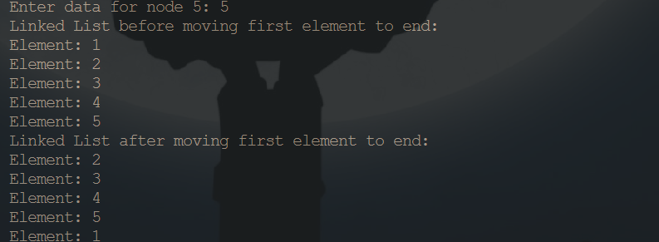

Category B
Problem 1
Remove duplicate elements from sorted linked list
#include <stdio.h>
#include <stdlib.h>
struct Node
{
int data;
struct Node *next;
};

void linkedlistTraversal(struct Node *ptr)
{
while (ptr != NULL)
{
printf("Element: %d\n", ptr->data);
ptr = ptr->next;
}
}

void removeDuplicates(struct Node *head)
{
struct Node *current = head;

while (current != NULL && current->next != NULL)
{
if (current->data == current->next->data)
{
struct Node *temp = current->next;
current->next = current->next->next;
free(temp);
}
else
{
current = current->next;
}
}
}
int main()
{
struct Node *head = NULL;
struct Node *last = NULL;
int n, data;
printf("Enter the data for nodes (enter -1 to stop):\n");
while (1)
{
printf("Enter data: ");
scanf("%d", &data);

if (data == -1)
{
break;
}

struct Node *newNode = (struct Node *)malloc(sizeof(struct Node));
newNode->data = data;
newNode->next = NULL;
if (head == NULL)
{
head = newNode;
last = newNode;
}
else
{
last->next = newNode;
last = newNode;
}
}
printf("Linked List before removing duplicates:\n");
linkedlistTraversal(head);
removeDuplicates(head);
printf("Linked List after removing duplicates:\n");
linkedlistTraversal(head);
return 0;
}
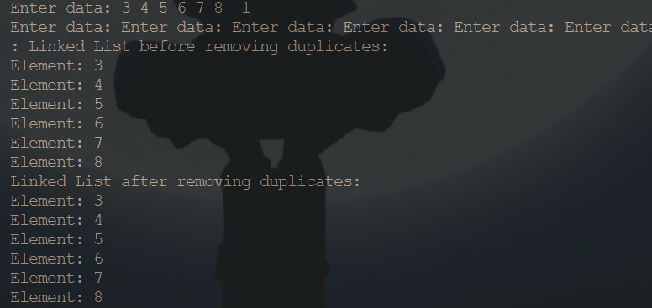
Problem 2
Detect loop in linked list
#include <stdbool.h>
#include <stdio.h>
#include <stdlib.h>
typedef struct Node
{
int data;
struct Node *next;
} Node;
void push(struct Node **head_ref, int new_data)
{
struct Node *new_node = (Node *)malloc(sizeof(Node));
new_node->data = new_data;
new_node->next = (*head_ref);
(*head_ref) = new_node;
}
bool detectLoop(struct Node *head)
{
struct Node *slow = head;
struct Node *fast = head;
while (fast != NULL && fast->next != NULL)
{
slow = slow->next;
fast = fast->next->next;
if (slow == fast)
{
return true;
}
}

return false;
}

int main()
{
struct Node *head = NULL;

push(&head, 20);
push(&head, 4);
push(&head, 15);
push(&head, 10);
head->next->next->next->next = head;
if (detectLoop(head))
{
printf("Loop Found\n");
}
else
{
printf("No Loop\n");
}
return 0;
}
Problem 3
Remove loop in linked list
#include <stdbool.h>
#include <stdio.h>
#include <stdlib.h>
typedef struct Node
{
int data;
struct Node *next;
} Node;

void push(struct Node **head_ref, int new_data)
{
struct Node *new_node = (Node *)malloc(sizeof(Node));
new_node->data = new_data;
new_node->next = (*head_ref);
(*head_ref) = new_node;
}
bool detectAndRemoveLoop(struct Node *head)
{
struct Node *slow = head;
struct Node *fast = head;
struct Node *prev = NULL;
while (fast != NULL && fast->next != NULL)
{
slow = slow->next;
prev = fast;
fast = fast->next->next;

if (slow == fast)
{
removeLoop(head, slow, prev);
return true;
}
}

return false;
}
void removeLoop(struct Node *head, struct Node *loopNode, struct Node *prev)
{
struct Node *ptr1 = head;
struct Node *ptr2 = loopNode;
while (ptr1 != ptr2)
{
ptr1 = ptr1->next;
prev = ptr2;
ptr2 = ptr2->next;
}
while (ptr2->next != loopNode)
{
ptr2 = ptr2->next;
}
ptr2->next = NULL;
}

int main()
{
struct Node *head = NULL;

push(&head, 20);
push(&head, 4);
push(&head, 15);
push(&head, 10);
head->next->next->next->next = head;
if (detectAndRemoveLoop(head))
{
printf("Loop Removed\n");
}
else
{
printf("No Loop\n");
}
return 0;
}
Problem 4
Function to check if a singly linked list is a palindrome
#include <stdio.h>
#include <stdlib.h>
#include <stdbool.h>

struct Node
{
int data;
struct Node *next;
};

void linkedlistTraversal(struct Node *ptr)
{
while (ptr != NULL)
{
printf("Element: %d\n", ptr->data);
ptr = ptr->next;
}
}
struct Node *reverseList(struct Node *head)
{
struct Node *prev = NULL;
struct Node *current = head;
struct Node *next = NULL;
while (current != NULL)
{
next = current->next;
current->next = prev;
prev = current;
current = next;
}
return prev;
}
bool isPalindrome(struct Node *head)
{
if (head == NULL || head->next == NULL)
return true;
struct Node *p = head;
struct Node *q = head;
while (p->next != NULL && p->next->next != NULL)
{
q = q->next;
p = p->next->next;
}
struct Node *secondHalf = reverseList(q->next);
struct Node *firstHalf = head;
while (secondHalf != NULL)
{
if (firstHalf->data != secondHalf->data)
return false;

firstHalf = firstHalf->next;
secondHalf = secondHalf->next;
}

return true;
}
int main()
{
struct Node *head = NULL;
struct Node *last = NULL;
int n, data;
printf("Enter the number of nodes: ");
scanf("%d", &n);
for (int i = 1; i <= n; i++)
{
printf("Enter data for node %d: ", i);
scanf("%d", &data);
struct Node *newNode = (struct Node *)malloc(sizeof(struct Node));
newNode->data = data;
newNode->next = NULL;
if (head == NULL)
{
head = newNode;
last = newNode;
}
else
{
last->next = newNode;
last = newNode;
}
}

printf("Linked List:\n");
linkedlistTraversal(head);

if (isPalindrome(head))
printf("The linked list is a palindrome.\n");
else
printf("The linked list is not a palindrome.\n");

return 0;
}
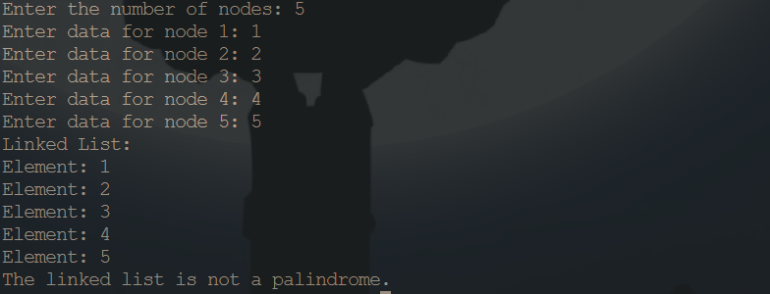
Problem 5
Delete last occurrence of an item from linked list
#include <stdio.h>
#include <stdlib.h>
typedef struct Node
{
int data;
struct Node *next;
} Node;
void insertEnd(Node **head, int data)
{
Node *newNode = (Node *)malloc(sizeof(Node));
newNode->data = data;
newNode->next = NULL;
if (*head == NULL)
{
*head = newNode;
return;
}
Node *temp = *head;
while (temp->next != NULL)
{
temp = temp->next;
}
temp->next = newNode;
}
void displayList(Node *head)
{
while (head != NULL)
{
printf("%d -> ", head->data);
head = head->next;
}
printf("NULL\n");
}
void deleteLastOccurrence(Node **head, int key)
{
if (*head == NULL)
{
printf("List is empty.\n");
return;
}

Node *temp = *head;
Node *lastOccur = NULL;
Node *prevLastOccur = NULL;
while (temp != NULL && temp->next != NULL)
{
if (temp->data == key)
{
prevLastOccur = lastOccur;
lastOccur = temp;
}
temp = temp->next;
}
if (lastOccur != NULL && lastOccur->data == key)
{
if (lastOccur == *head)
{
*head = lastOccur->next;
}
else
{ prevLastOccur->next = lastOccur->next;
}

free(lastOccur);
printf("Last occurrence of %d deleted.\n", key);
}
else
{
printf("Element not found in the list.\n");
}
}
void freeList(Node *head)
{
Node *temp;
while (head != NULL)
{
temp = head;
head = head->next;
free(temp);
}
}

int main()
{
Node *head = NULL;
insertEnd(&head, 2);
insertEnd(&head, 3);
insertEnd(&head, 2);
insertEnd(&head, 4);
insertEnd(&head, 2);
insertEnd(&head, 5);
printf("Original Linked List: ");
displayList(head);
int key;
printf("Enter the element to delete its last occurrence: ");
scanf("%d", &key);
deleteLastOccurrence(&head, key);
printf("Linked List after deletion: ");
displayList(head);
freeList(head);
return 0;
}
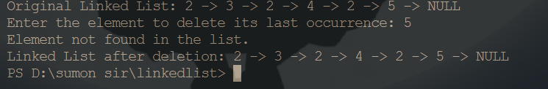
Problem 6
Print the Middle of a given linked list
#include <stdio.h>
#include <stdlib.h>

struct Node
{
int data;
struct Node *next;
};
void push(struct Node **head_ref, int new_data)
{
struct Node *new_node = (struct Node *)malloc(sizeof(struct Node));
new_node->data = new_data;
new_node->next = NULL;

if (*head_ref == NULL)
{
*head_ref = new_node;
return;
}

struct Node *last = *head_ref;
while (last->next != NULL)
{
last = last->next;
}

last->next = new_node;
}
void printList(struct Node *head)
{
struct Node *temp = head;
while (temp != NULL)
{
printf("%d ", temp->data);
temp = temp->next;
}
printf("\n");
}
void printMiddle(struct Node *head)
{
struct Node *slow_ptr = head;
struct Node *fast_ptr = head;

if (head != NULL)
{
while (fast_ptr != NULL && fast_ptr->next != NULL)
{
fast_ptr = fast_ptr->next->next;
slow_ptr = slow_ptr->next;
}
printf("The middle element is [ %d ]\n", slow_ptr->data);
}
}
int main()
{
struct Node *head = NULL;
int i;
for (i = 5; i >= 0; i--)
{
push(&head, i);
printList(head);
printMiddle(head);
}

return 0;
}
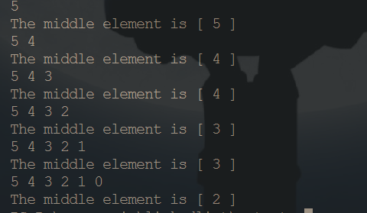

Category C
Problem 1
Flattening a linked list
#include <stdio.h>
#include <stdlib.h>
struct Node {
int data;
struct Node *next, *bottom;
};
struct Node* head = NULL;
struct Node* merge(struct Node* a, struct Node* b) {
if (a == NULL) return b;
if (b == NULL) return a;
struct Node* result;
if (a->data < b->data) {
result = a;
result->bottom = merge(a->bottom, b);
} else {
result = b;
result->bottom = merge(a, b->bottom);
}

result->next = NULL;
return result;
}
struct Node* flatten(struct Node* root) {
if (root == NULL || root->next == NULL) return root;
root->next = flatten(root->next);
root = merge(root, root->next);
return root;
}
struct Node* push(struct Node* head_ref, int data) {
struct Node* new_node = (struct Node*)malloc(sizeof(struct Node));
new_node->data = data;
new_node->next = NULL;
new_node->bottom = head_ref;
head_ref = new_node;
return head_ref;
}
void printList() {
struct Node* temp = head;
while (temp != NULL) {
printf("%d ", temp->data);
temp = temp->bottom;
}
printf("\n");
}
int main() {
head = push(head, 30);
head = push(head, 8);
head = push(head, 7);
head = push(head, 5);

head->next = push(head->next, 20);
head->next = push(head->next, 10);

head->next->next = push(head->next->next, 50);
head->next->next = push(head->next->next, 22);
head->next->next = push(head->next->next, 19);

head->next->next->next = push(head->next->next->next, 45);
head->next->next->next = push(head->next->next->next, 40);
head->next->next->next = push(head->next->next->next, 35);
head->next->next->next = push(head->next->next->next, 28);

head = flatten(head);
printList();
return 0;
}
Problem 2
C program to delete N nodes after M nodes of a linked list
#include <stdio.h>
#include <stdlib.h>
struct Node
{
int data;
struct Node *next;
};
void push(struct Node **head_ref, int new_data)
{
struct Node *new_node = (struct Node *)malloc(sizeof(struct Node));
new_node->data = new_data;
new_node->next = (*head_ref);
(*head_ref) = new_node;
}
void printList(struct Node *head)
{
struct Node *temp = head;
while (temp != NULL)
{
printf("%d ", temp->data);
temp = temp->next;
}
printf("\n");
}
void skipMdeleteN(struct Node *head, int M, int N)
{
struct Node *curr = head, *t;
int count;
while (curr)
{
for (count = 1; count < M && curr != NULL; count++)
curr = curr->next;
if (curr == NULL)
return;
t = curr->next;
for (count = 1; count <= N && t != NULL; count++)
{
struct Node *temp = t;
t = t->next;
free(temp);
}
curr->next = t;
curr = t;
}
}
int main()
{
1->2->3->4->5->6->7->8->9->10 */
struct Node *head = NULL;
int M = 2, N = 3;
push(&head, 10);
push(&head, 9);
push(&head, 8);
push(&head, 7);
push(&head, 6);
push(&head, 5);
push(&head, 4);
push(&head, 3);
push(&head, 2);
push(&head, 1);

printf("M = %d, N = %d \nGiven Linked list is :\n", M, N);
printList(head);
skipMdeleteN(head, M, N);
printf("\nLinked list after deletion is :\n");
printList(head);
return 0;
}

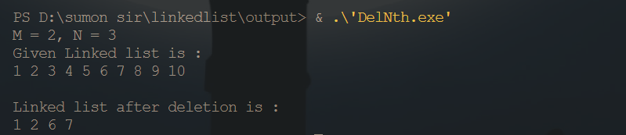
Problem 3
C program to merge a linked list into another at
alternate positions
#include <stdio.h>
#include <stdlib.h>
struct Node
{
int data;
struct Node *next;
};
void push(struct Node **head_ref, int new_data)
{
struct Node *new_node =
(struct Node *)malloc(sizeof(struct Node));
new_node->data = new_data;
new_node->next = (*head_ref);
(*head_ref) = new_node;
}
void printList(struct Node *head)
{
struct Node *temp = head;
while (temp != NULL)
{
printf("%d ", temp->data);
temp = temp->next;
}
printf("\n");
}
void merge(struct Node *p, struct Node **q)
{
struct Node *p_curr = p, *q_curr = *q;
struct Node *p_next, *q_next;
while (p_curr != NULL && q_curr != NULL)
{
p_next = p_curr->next;
q_next = q_curr->next;

q_curr->next = p_next;
p_curr->next = q_curr;
p_curr = p_next;
q_curr = q_next;
}

*q = q_curr;
}
int main()
{
struct Node *p = NULL, *q = NULL;
push(&p, 3);
push(&p, 2);
push(&p, 1);
printf("First Linked List:\n");
printList(p);

push(&q, 8);
push(&q, 7);
push(&q, 6);
push(&q, 5);
push(&q, 4);
printf("Second Linked List:\n");
printList(q);
merge(p, &q);
printf("Modified First Linked List:\n");
printList(p);
printf("Modified Second Linked List:\n");
printList(q);
getchar();
return 0;
}
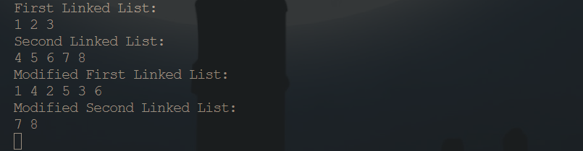
Problem 4
Binary Search in a Linked List
#include <stdio.h>
#include <stdlib.h>
struct Node
{
int data;
struct Node *next;
};
struct Node *createNode(int data)
{
struct Node *newNode = (struct Node *)malloc(sizeof(struct Node));
newNode->data = data;
newNode->next = NULL;
return newNode;
}
struct Node *insertAtEnd(struct Node *head, int data)
{
struct Node *newNode = createNode(data);

if (head == NULL)
{
return newNode;
}
struct Node *temp = head;
while (temp->next != NULL)
{
temp = temp->next;
}

temp->next = newNode;
return head;
}
struct Node *binarySearch(struct Node *head, int target)
{
struct Node *low = head;
struct Node *high = NULL;
int length = 0;
struct Node *temp = head;
while (temp != NULL)
{
length++;
temp = temp->next;
}

high = temp = head;
while (low != NULL && high != NULL && low != high->next)
{
int midIndex = (length - 1) / 2;
struct Node *mid = temp;
for (int i = 0; i < midIndex; i++)
{
mid = mid->next;
}

if (mid->data == target)
{
return mid;
}
else if (mid->data < target)
{
low = mid->next;
}
else
{
high = mid;
}
}
return NULL;
}
void printLinkedList(struct Node *head)
{
struct Node *temp = head;
while (temp != NULL)
{
printf("%d ", temp->data);
temp = temp->next;
}
printf("\n");
}

int main()
{
struct Node *head = NULL;
int data;
printf("Enter elements for the sorted linked list (enter -1 to stop):\n");
while (1)
{
printf("Enter element: ");
scanf("%d", &data);

if (data == -1)
{
break;
}

head = insertAtEnd(head, data);
}
printf("Linked List: ");
printLinkedList(head);
int target;
printf("Enter the element to search: ");
scanf("%d", &target);
struct Node *result = binarySearch(head, target);
if (result != NULL)
{
printf("Element %d found in the linked list.\n", target);
}
else
{
printf("Element %d not found in the linked list.\n", target);
}
return 0;
}
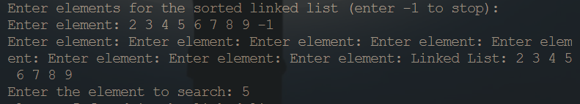
Problem 5
Reverse a linked list using 2 pointers technique using XOR operator
#include <stdio.h>
#include <stdlib.h>
struct Node
{
int data;
struct Node *next;
};
struct Node *head = NULL;
void insertNode(int pos, int x)
{
struct Node *temp = (struct Node *)malloc(sizeof(struct Node));
if (temp == NULL)
{
printf("Insert not possible\n");
return;
}
temp->data = x;
if (pos == 1)
{
temp->next = head;
head = temp;
}
else
{
int i = 1;
struct Node *thptr = head;
while (i < pos - 1)
{
thptr = thptr->next;
i++;
}
temp->next = thptr->next;
thptr->next = temp;
}
}
void reverseList()
{
struct Node *current = head;
struct Node *next;
struct Node *prev = NULL;

while (current != NULL)
{
next = current->next;
current->next = prev;
prev = current;
current = next;
}
head = prev;
}
void print()
{
struct Node *temp = head;
while (temp != NULL)
{
printf("%d\n", temp->data);
temp = temp->next;
}
}
int main()
{
insertNode(1, 10);
insertNode(2, 20);
insertNode(3, 30);
insertNode(4, 40);
insertNode(5, 50);

reverseList();
print();
return 0;
}
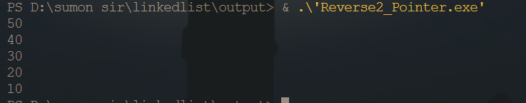

GRAPH PROBLEM
Problem 1
Write a C Program to represent a graph using the concept of adjacency matrix.
#include <stdio.h>
int main()
{
int no_vertices;
printf("Enter the number of vertices: ");
scanf("%d", &no_vertices);
int adj[no_vertices][no_vertices];
for (int i = 0; i < no_vertices; i++)
{
for (int j = 0; j < no_vertices; j++)
{
adj[i][j] = 0;
}
}
int source, destination;
do
{
printf("Enter the edge (source, destination): ");
scanf("%d %d", &source, &destination);
if (source < 0 || source >= no_vertices || destination < 0 || destination >= no_vertices)
{
printf("Invalid vertex: Please enter values between 0 and %d.\n", no_vertices - 1);
continue;
}
adj[source][destination] = 1;
adj[destination][source] = 1;
} while (source != -1 && destination != -1);
printf("\nAdjacency Matrix:\n");
for (int i = 0; i < no_vertices; i++)
{
for (int j = 0; j < no_vertices; j++)
{
printf("%d ", adj[i][j]);
}
printf("\n");
}
return 0;
}
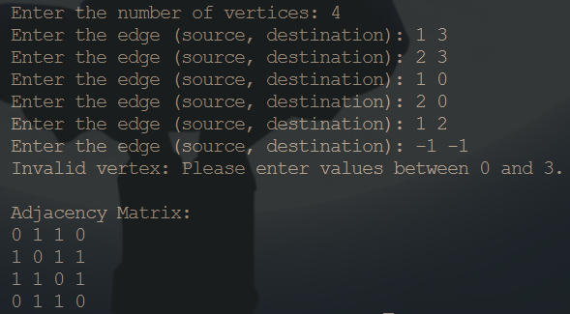
Problem 2
Write a C Program to represent a graph using the concept of adjacency List.
#include <stdio.h>
#include <stdlib.h>
typedef struct Node
{
int data;
struct Node *next;
} Node;
typedef struct List
{
Node *head;
} List;
typedef struct Graph
{
int num_vertices;
List *adj_lists;
} Graph;
Node *createNode(int data)
{
Node *newNode = malloc(sizeof(Node));
newNode->data = data;
newNode->next = NULL;
return newNode;
}
Graph *initializeGraph(int num_vertices)
{
Graph *graph = malloc(sizeof(Graph));
graph->num_vertices = num_vertices;
graph->adj_lists = malloc(sizeof(List) * num_vertices);
for (int i = 0; i < num_vertices; i++)
{
graph->adj_lists[i].head = NULL;
}
return graph;
}
void addEdge(Graph *graph, int source, int destination)
{
Node *newNode = createNode(destination);
newNode->next = graph->adj_lists[source].head;
graph->adj_lists[source].head = newNode;
newNode = createNode(source);
newNode->next = graph->adj_lists[destination].head;
graph->adj_lists[destination].head = newNode;
}
void printGraph(Graph *graph)
{
for (int i = 0; i < graph->num_vertices; i++)
{
printf("Vertex %d: ", i);
Node *temp = graph->adj_lists[i].head;
while (temp != NULL)
{
printf("%d -> ", temp->data);
temp = temp->next;
}
printf("NULL\n");
}
}
int main()
{
int num_vertices, source, destination;
printf("Enter the number of vertices: ");
scanf("%d", &num_vertices);
Graph *graph = initializeGraph(num_vertices);
do
{
printf("Enter the edge (source, destination): ");
scanf("%d %d", &source, &destination);
if (source < 0 || source >= num_vertices || destination < 0 || destination >= num_vertices)
{
printf("Invalid vertex: Please enter values between 0 and %d.\n", num_vertices - 1);
continue;
}
addEdge(graph, source, destination);
} while (source != -1 && destination != -1);
printGraph(graph);
return 0;
}
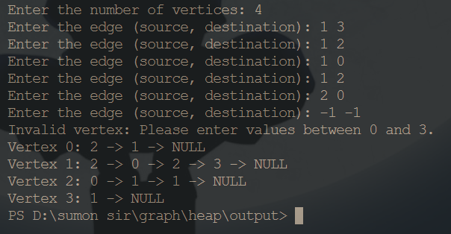
Problem 3
Implement Graph traversal algorithm BFS and DFS using C
#include <stdio.h
#define MAX 10
void breadth_first_search(int adj[][MAX], int visited[], int start) {
int queue[MAX], rear = 0, front = 0, i, k;
for (k = 0; k < MAX; k++) {
visited[k] = 0;
} queue[rear++] = start;
visited[start] = 1;
while (rear > front) {
start = queue[front++];
printf("%c ", start + 65);
for (i = 0; i < MAX; i++) {
if (adj[start][i] == 1 && visited[i] == 0) {
queue[rear++] = i;
visited[i] = 1;
}
}
}
}
void depth_first_search(int adj[][MAX], int visited[], int start) {
int stack[MAX], top = -1, i, k;
for (k = 0; k < MAX; k++) {
visited[k] = 0;
}
stack[++top] = start;
visited[start] = 1;
while (top != -1) {
start = stack[top--];
printf("%c ", start + 65);
for (i = 0; i < MAX; i++) {
if (adj[start][i] == 1 && visited[i] == 0) {
stack[++top] = i;
visited[i] = 1;
}
}
}
}

int main() {
int visited[MAX] = {0};
int adj[MAX][MAX], i, j;
int option, size;
do {
printf("\n 1. Enter values in graph");
printf("\n 2. BFS Traversal");
printf("\n 3. DFS Traversal");
printf("\n 4. Exit");
printf("\n\n Enter your option: ");
scanf("%d", &option);
switch (option) {
case 1:
printf("\n Enter the adjacency matrix:\n");
for (i = 0; i < MAX; i++) {
for (j = 0; j < MAX; j++) {
scanf("%d", &adj[i][j]);
}
}
break;
case 2:
printf("BFS Traversal: ");
breadth_first_search(adj, visited, 0); // Assuming starting vertex is 0
printf("\n");
break;
case 3:
printf("DFS Traversal: ");
depth_first_search(adj, visited, 0);
printf("\n");
break;
case 4:
printf("\n Exiting...\n");
break;
default:
printf("\n Invalid option. Please enter again.\n");
break;
}
} while (option != 4);
return 0;
}
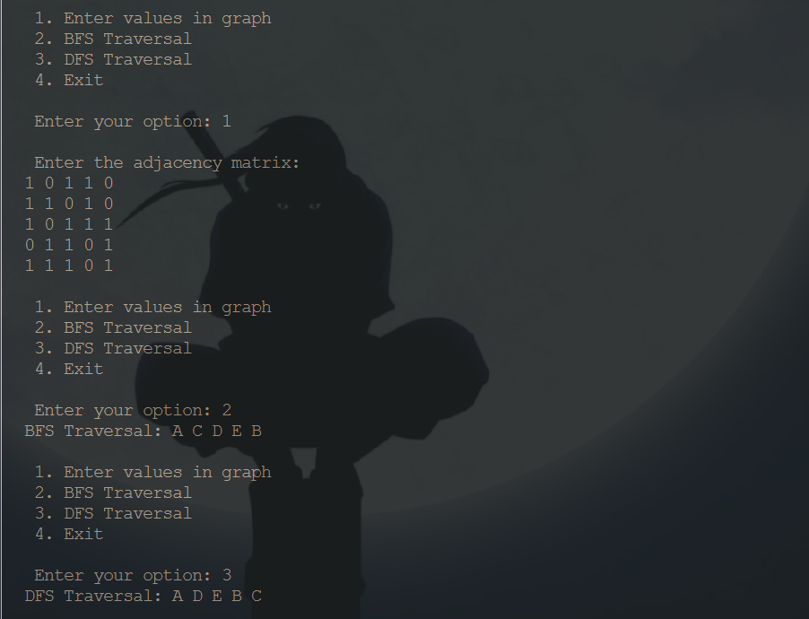
Problem 04
Implement Floyd Wars halls algorithm using C language
#include <stdio.h>
#include <limits.h>
#define V 4
void printSolution(int dist[][V]);
void floydWarshall(int graph[][V]) {
int dist[V][V];
for (int i = 0; i < V; i++)
for (int j = 0; j < V; j++)
dist[i][j] = graph[i][j];
for (int k = 0; k < V; k++) {
for (int i = 0; i < V; i++) {
for (int j = 0; j < V; j++) {
if (dist[i][k] != INT_MAX && dist[k][j] != INT_MAX &&
dist[i][k] + dist[k][j] < dist[i][j]) {
dist[i][j] = dist[i][k] + dist[k][j];
}
}
}
}
printSolution(dist);
}
void printSolution(int dist[][V]) {
printf("Shortest distances between every pair of vertices:\n");
for (int i = 0; i < V; i++) {
for (int j = 0; j < V; j++) {
if (dist[i][j] == INT_MAX)
printf("INF\t");
else
printf("%d\t", dist[i][j]);
}
printf("\n");
}
}
int main() {
int graph[V][V] = {
{0, 3, INT_MAX, 5},
{2, 0, INT_MAX, 4},
{INT_MAX, 1, 0, INT_MAX},
{INT_MAX, INT_MAX, 2, 0}};
floydWarshall(graph);
return 0;
}
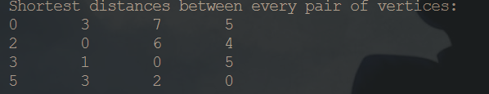
Problem 5
Find out the minimum spanning trees using Prims and Kruskal algorithm
#include <stdio.h>
#include <stdlib.h>
#include <limits.h>
#define V 5
int minKey(int key[], int mstSet[])
{
int min = INT_MAX, min_index;
for (int v = 0; v < V; v++)
{
if (mstSet[v] == 0 && key[v] < min)
{
min = key[v];
min_index = v;
}
}
return min_index;
}
void printMST(int parent[], int graph[V][V])
{
printf("Edge \tWeight\n");
for (int i = 1; i < V; i++)
{
printf("%d - %d \t%d \n", parent[i], i, graph[i][parent[i]]);
}
}
void primMST(int graph[V][V])
{
int parent[V];
int key[V];
int mstSet[V];
for (int i = 0; i < V; i++)
{
key[i] = INT_MAX;
mstSet[i] = 0;
}
key[0] = 0;
parent[0] = -1;
for (int count = 0; count < V - 1; count++)
{
int u = minKey(key, mstSet);

mstSet[u] = 1;

for (int v = 0; v < V; v++)
{
if (graph[u][v] && mstSet[v] == 0 && graph[u][v] < key[v])
{
parent[v] = u;
key[v] = graph[u][v];
}
}
}
printMST(parent, graph);
}

int main()
{
int graph[V][V] = {{0, 2, 0, 6, 0},
{2, 0, 3, 8, 5},
{0, 3, 0, 0, 7},
{6, 8, 0, 0, 9},
{0, 5, 7, 9, 0}};

primMST(graph);
return 0;
}
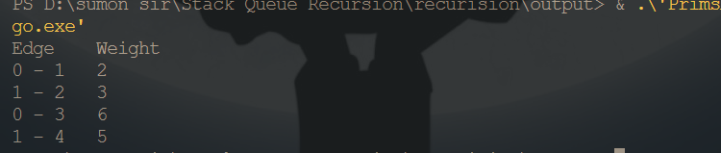

Tree Problem

Part A
Problem 1
Write a C program for tree traversals.
#include <stdio.h>
#include <stdlib.h>
struct Node
{
int data;
struct Node *left;
struct Node *right;
};
struct Node *createNode(int data)
{
struct Node *n;
n = (struct Node *)malloc(sizeof(struct Node));
n->data = data;
n->left = NULL;
n->right = NULL;
return n;
}
struct Node *insertNode(struct Node *root, int data)
{
if (root == NULL)
{
return createNode(data);
}
else
{
if (data <= root->data)
{
root->left = insertNode(root->left, data);
}
else
{
root->right = insertNode(root->right, data);
}
return root;
}
}
void print(struct Node *root)
{
if (root == NULL)
{
return;
}
else
{
print(root->left);
printf("%d ", root->data);
print(root->right);
}
}
void preOrder(struct Node *root)
{
if (root != NULL)
{
printf("%d ", root->data);
preOrder(root->left);
preOrder(root->right);
}
}
void inOrder(struct Node *root)
{
if (root != NULL)
{
inOrder(root->left);
printf("%d ", root->data);
inOrder(root->right);
}
}
void postOrder(struct Node *root)
{
if (root != NULL)
{
postOrder(root->left);
postOrder(root->right);
printf("%d ", root->data);
}
}
int main()
{
struct Node *root = NULL;
int val;
printf("Enter the values for the nodes (enter -1 to stop):\n");
while (1)
{
scanf("%d", &val);
if (val == -1)
break;
root = insertNode(root, val);
}
printf("Orginal array");
print(root);
printf("\n");
printf("Pre-Order Traversal: ");
preOrder(root);
printf("\n");
printf("In-Order Traversal: ");
inOrder(root);
printf("\n");
printf("Post-Order Traversal: ");
postOrder(root);
printf("\n");
return 0;
}
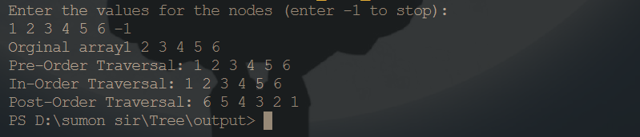
Problem 2
Write a C program to find the Maximum depth or height of a tree.
#include <stdio.h>
#include <stdlib.h>
struct Node
{
int data;
struct Node *left;
struct Node *right;
};
struct Node *createNode(int data)
{
struct Node *n = (struct Node *)malloc(sizeof(struct Node));
n->data = data;
n->left = NULL;
n->right = NULL;
return n;
}
struct Node *insertNode(struct Node *root, int data)
{
if (root == NULL)
{
return createNode(data);
}
else
{
if (data <= root->data)
{
root->left = insertNode(root->left, data);
}
else
{
root->right = insertNode(root->right, data);
}
return root;
}
}
int findMaxDepth(struct Node *root)
{
if (root == NULL)
{
return 0;
}
else
{
int leftDepth = findMaxDepth(root->left);
int rightDepth = findMaxDepth(root->right);
if(leftDepth > rightDepth){
return leftDepth + 1;
}else{
return rightDepth + 1;
}
}
}

int main()
{
struct Node *root = NULL;
int val;
printf("Enter the values for the nodes (enter -1 to stop):\n");
while (1)
{
scanf("%d", &val);
if (val == -1)
break;
root = insertNode(root, val);
}
int maxDepth = findMaxDepth(root);
printf("Maximum Depth of the Binary Tree: %d\n", maxDepth);
return 0;
}
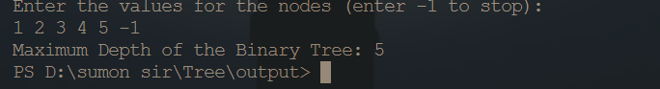
Problem 3
Write a C program to delete a node.
#include <stdio.h>
#include <stdlib.h>
struct Node
{
int data;
struct Node *left;
struct Node *right;
};
struct Node *createNode(int data)
{
struct Node *n;
n = (struct Node *)malloc(sizeof(struct Node));
n->data = data;
n->left = NULL;
n->right = NULL;
return n;
}
struct Node *insertNode(struct Node *root, int data)
{
if (root == NULL)
{
return createNode(data);
}
else
{
if (data <= root->data)
{
root->left = insertNode(root->left, data);
}
else
{
root->right = insertNode(root->right, data);
}
return root;
}
}
struct Node *minValueNode(struct Node *node)
{
struct Node *current = node;
while (current && current->left != NULL)
{
current = current->left;
}

return current;
}
struct Node *deleteNode(struct Node *root, int key)
{
if (root == NULL)
{
return root;
}
if (key < root->data)
{
root->left = deleteNode(root->left, key);
}
else if (key > root->data)
{
root->right = deleteNode(root->right, key);
}
else
{
if (root->left == NULL)
{
struct Node *temp = root->right;
free(root);
return temp;
}
else if (root->right == NULL)
{
struct Node *temp = root->left;
free(root);
return temp;
}
struct Node *temp = minValueNode(root->right);
root->data = temp->data;
root->right = deleteNode(root->right, temp->data);
}
return root;
}

void inOrder(struct Node *root)
{
if (root != NULL)
{
inOrder(root->left);
printf("%d ", root->data);
inOrder(root->right);
}
}
int main()
{
struct Node *root = NULL;
int val;
printf("Enter the values for the nodes (enter -1 to stop):\n");
while (1)
{
scanf("%d", &val);
if (val == -1)
break;
root = insertNode(root, val);
}
printf("In-Order Traversal: ");
inOrder(root);
printf("\n");
int key;
printf("Enter the value to delete: ");
scanf("%d", &key);
root = deleteNode(root, key);
printf("In-Order Traversal after deletion: ");
inOrder(root);
printf("\n");

return 0;
}
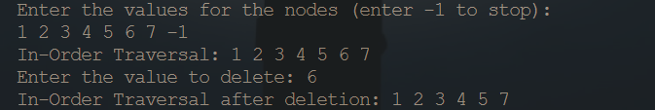
Problem 4
Find the node with minimum value in a binary search tree.
#include <stdio.h>
#include <stdlib.h>
#include <limits.h>
struct Node
{
int data;
struct Node *left;
struct Node *right;
};
struct Node *createNode(int data)
{
struct Node *n = (struct Node *)malloc(sizeof(struct Node));
n->data = data;
n->left = NULL;
n->right = NULL;
return n;
}
struct Node *insertNode(struct Node *root, int data)
{
if (root == NULL)
{
return createNode(data);
}
else
{
if (data <= root->data)
{
root->left = insertNode(root->left, data);
}
else
{
root->right = insertNode(root->right, data);
}
return root;
}
}
void inOrder(struct Node *root)
{
if (root != NULL)
{
inOrder(root->left);
printf("%d ", root->data);
inOrder(root->right);
}
}
struct Node *findMinValueNode(struct Node *root)
{
struct Node *current = root;
while (current != NULL && current->left != NULL)
{
current = current->left;
}

return current;
}
int isBST(struct Node *root, int min, int max)
{
if (root == NULL)
{
return 1;
}

if (root->data < min || root->data > max)
{
return 0;
}
return isBST(root->left, min, root->data - 1) && isBST(root->right, root->data + 1, max);
}
int main()
{
struct Node *root = NULL;
int val;
printf("Enter the values for the nodes (enter -1 to stop):\n");
while (1)
{
scanf("%d", &val);
if (val == -1)
break;
root = insertNode(root, val);
}
printf("In-Order Traversal: ");
inOrder(root);
printf("\n");
if (isBST(root, INT_MIN, INT_MAX))
{
printf("The binary tree is a Binary Search Tree (BST).\n");
struct Node *minNode = findMinValueNode(root);
if (minNode != NULL)
{
printf("Node with minimum value: %d\n", minNode->data);
}
else
{
printf("The tree is empty.\n");
}
}
else
{
printf("The binary tree is not a Binary Search Tree (BST).\n");
}
return 0;
}
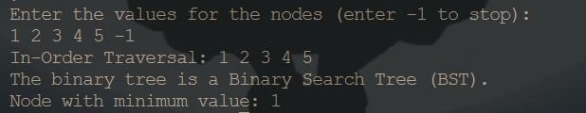
Problem 5
Program to count leaf nodes in a binary tree
#include <stdio.h>
#include <stdlib.h>
struct Node
{
int data;
struct Node *left;
struct Node *right;
};
struct Node *createNode(int data)
{
struct Node *n = (struct Node *)malloc(sizeof(struct Node));
n->data = data;
n->left = NULL;
n->right = NULL;
return n;
}
struct Node *insertNode(struct Node *root, int data)
{
if (root == NULL)
{
return createNode(data);
}
else
{
if (data <= root->data)
{
root->left = insertNode(root->left, data);
}
else
{
root->right = insertNode(root->right, data);
}
return root;
}
}
void inOrder(struct Node *root)
{
if (root != NULL)
{
inOrder(root->left);
printf("%d ", root->data);
inOrder(root->right);
}
}
int countLeafNodes(struct Node *root)
{
if (root == NULL)
{
return 0;
}
if (root->left == NULL && root->right == NULL)
{
return 1;
}
else
{
return countLeafNodes(root->left) + countLeafNodes(root->right);
}
}

int main()
{
struct Node *root = NULL;
int val;
printf("Enter the values for the nodes (enter -1 to stop):\n");
while (1)
{
scanf("%d", &val);
if (val == -1)
break;
root = insertNode(root, val);
}
printf("In-Order Traversal: ");
inOrder(root);
printf("\n");
int leafCount = countLeafNodes(root);
printf("Number of leaf nodes: %d\n", leafCount);
return 0;
}
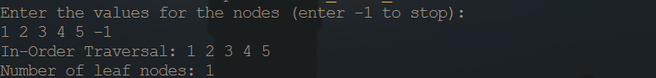

Part- B
Problem 6
Write C code to determine if two trees are identical
#include <stdio.h>
#include <stdlib.h>
struct Node
{
int data;
struct Node *left;
struct Node *right;
};
struct Node *createNode(int data)
{
struct Node *n = (struct Node *)malloc(sizeof(struct Node));
n->data = data;
n->left = NULL;
n->right = NULL;
return n;
}
struct Node *insertNode(struct Node *root, int data)
{
if (root == NULL)
{
return createNode(data);
}
else
{
if (data <= root->data)
{
root->left = insertNode(root->left, data);
}
else
{
root->right = insertNode(root->right, data);
}
return root;
}
}
void inOrder(struct Node *root)
{
if (root != NULL)
{
inOrder(root->left);
printf("%d ", root->data);
inOrder(root->right);
}
}
int areIdentical(struct Node *root1, struct Node *root2)
{
if (root1 == NULL && root2 == NULL)
return 1;
if (root1 == NULL&& root2 != NULL|| root1 != NULL && root2 == NULL)
return 0;
return (root1->data == root2->data) &&
areIdentical(root1->left, root2->left) &&
areIdentical(root1->right, root2->right);
}
int main()
{
struct Node *root1 = NULL;
struct Node *root2 = NULL;
int val;
printf("Enter the values for the nodes of the first tree (enter -1 to stop):\n");
while (1)
{
scanf("%d", &val);
if (val == -1)
break;
root1 = insertNode(root1, val);
}
printf("Enter the values for the nodes of the second tree (enter -1 to stop):\n");
while (1)
{
scanf("%d", &val);
if (val == -1)
break;
root2 = insertNode(root2, val);
}
printf("In-Order Traversal of the first tree: ");
inOrder(root1);
printf("\n");
printf("In-Order Traversal of the second tree: ");
inOrder(root2);
printf("\n");
if (areIdentical(root1, root2))
{
printf("The two trees are identical.\n");
}
else
{
printf("The two trees are not identical.\n");
}
return 0;
}
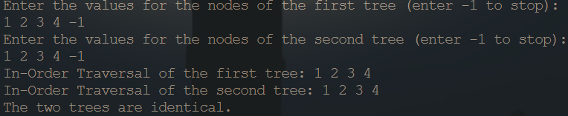
Problem 7
Construct complete binary tree from its linked list representation.
#include <stdio.h>
#include <stdlib.h>
struct ListNode
{
int data;
struct ListNode *next;
};
struct TreeNode
{
int data;
struct TreeNode *left;
struct TreeNode *right;
};
struct ListNode *createListNode(int data)
{
struct ListNode *node = (struct ListNode *)malloc(sizeof(struct ListNode));
node->data = data;
node->next = NULL;
return node;
}
struct TreeNode *createTreeNode(int data)
{
struct TreeNode *node = (struct TreeNode *)malloc(sizeof(struct TreeNode));
node->data = data;
node->left = NULL;
node->right = NULL;
return node;
}
struct ListNode *insertListNode(struct ListNode *head, int data)
{
struct ListNode *newNode = createListNode(data);
if (head == NULL)
{
return newNode;
}
struct ListNode *current = head;
while (current->next != NULL)
{
current = current->next;
}

current->next = newNode;
return head;
}
void printLinkedList(struct ListNode *head)
{
while (head != NULL)
{
printf("%d -> ", head->data);
head = head->next;
}
printf("NULL\n");
}
struct ListNode *treeToList(struct TreeNode *root, struct ListNode **tail)
{
if (root == NULL)
{
return NULL;
}
struct ListNode *leftList = treeToList(root->left, tail);
struct ListNode *currentNode = createListNode(root->data);
if (*tail == NULL)
{
*tail = currentNode;
}
else
{
(*tail)->next = currentNode;
*tail = currentNode;
}

struct ListNode *rightList = treeToList(root->right, tail);

return (leftList != NULL) ? leftList : currentNode;
}
void inOrder(struct TreeNode *root)
{
if (root != NULL)
{
inOrder(root->left);
printf("%d ", root->data);
inOrder(root->right);
}
}

int main()
{
struct ListNode *head = NULL;
int val;
printf("Enter the values for the linked list (enter -1 to stop):\n");
while (1)
{
scanf("%d", &val);
if (val == -1)
break;
head = insertListNode(head, val);
}
printf("Linked List: ");
printLinkedList(head);
struct TreeNode *root = listToTree(head);
printf("In-Order Traversal of the Binary Tree: ");
inOrder(root);
printf("\n");
return 0;
}
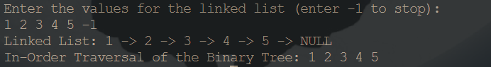
Problem 8
Write a program for iterative post-order traversal | Set 2 (Using One Stack
#include <stdio.h>
#include <stdlib.h>
struct TreeNode
{
int data;
struct TreeNode *left;
struct TreeNode *right;
};
struct StackNode
{
struct TreeNode *node;
struct StackNode *next;
};
struct TreeNode *createTreeNode(int data)
{
struct TreeNode *node = (struct TreeNode *)malloc(sizeof(struct TreeNode));
node->data = data;
node->left = NULL;
node->right = NULL;
return node;
}
struct StackNode *createStackNode(struct TreeNode *node)
{
struct StackNode *stackNode = (struct StackNode *)malloc(sizeof(struct StackNode));
stackNode->node = node;
stackNode->next = NULL;
return stackNode;
}
void push(struct StackNode **stack, struct TreeNode *node)
{
struct StackNode *stackNode = createStackNode(node);
stackNode->next = *stack;
*stack = stackNode;
}
struct TreeNode *pop(struct StackNode **stack)
{
if (*stack == NULL)
return NULL;
struct StackNode *temp = *stack;
*stack = (*stack)->next;
struct TreeNode *popped = temp->node;
free(temp);
return popped;
}
void postOrderIterative(struct TreeNode *root)
{
if (root == NULL)
return;
struct StackNode *stack = NULL;
do
{
while (root)
{
if (root->right)
push(&stack, root->right);
push(&stack, root);
root = root->left;
}
root = pop(&stack);
if (root->right && stack && root->right == stack->node)
{
pop(&stack);
push(&stack, root);
root = root->right;
}
else
{
printf("%d ", root->data);
root = NULL;
}
} while (stack != NULL);
}

int main()
{
struct TreeNode *root = createTreeNode(1);
root->left = createTreeNode(2);
root->right = createTreeNode(3);
root->left->left = createTreeNode(4);
root->left->right = createTreeNode(5);
printf("Iterative Post-Order Traversal: ");
postOrderIterative(root);
printf("\n");
return 0;
}
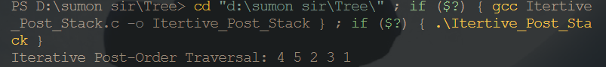

Problem 9
Write a code in-order tree traversal without recursion and without stack!
#include <stdio.h>
#include <stdlib.h>
struct Node
{
int data;
struct Node *left;
struct Node *right;
};
struct Node *createNode(int data)
{
struct Node *n;
n = (struct Node *)malloc(sizeof(struct Node));
n->data = data;
n->left = NULL;
n->right = NULL;
return n;
}
struct Node *insertNode(struct Node *root, int data)
{
if (root == NULL)
{
return createNode(data);
}
else
{
if (data <= root->data)
{
root->left = insertNode(root->left, data);
}
else
{
root->right = insertNode(root->right, data);
}
return root;
}
}
void inOrderTraversal(struct Node *root)
{
struct Node *current = root;
struct Node *prev = NULL;
while (current != NULL)
{
while (current->left != NULL && current->left != prev)
{
prev = current;
current = current->left;
}
printf("%d ", current->data);
if (current->right == NULL)
{
current = prev;
prev = NULL;
}
else
{
current = current->right;
prev = NULL;
break;
}
}
}
int main()
{
struct Node *root = NULL;
int val;
printf("Enter the values for the nodes (enter -1 to stop):\n");
while (1)
{
scanf("%d", &val);
if (val == -1)
break;
root = insertNode(root, val);
}
printf("In-Order Traversal: ");
inOrderTraversal(root);
printf("\n");
return 0;
}
Problem 10
How to determine if a binary tree is height-balanced?
#include <stdio.h>
#include <stdlib.h>
struct Node
{
int data;
struct Node *left;
struct Node *right;
};
struct Node *createNode(int data)
{
struct Node *n;
n = (struct Node *)malloc(sizeof(struct Node));
n->data = data;
n->left = NULL;
n->right = NULL;
return n;
}
struct Node *insertNode(struct Node *root, int data)
{
if (root == NULL)
{
return createNode(data);
}
else
{
if (data <= root->data)
{
root->left = insertNode(root->left, data);
}
else
{
root->right = insertNode(root->right, data);
}
return root;
}
}
int height(struct Node *root)
{
if (root == NULL)
{
return 0;
}
else
{
int leftHeight = height(root->left);
int rightHeight = height(root->right);
if(leftHeight > rightHeight){
return leftHeight + 1;
}
else{
return rightHeight + 1;
}
}
}
int isHeightBalanced(struct Node *root)
{
if (root == NULL)
{
return 1;
}
int leftHeight = height(root->left);
int rightHeight = height(root->right);
if (abs(leftHeight - rightHeight) <= 1 && isHeightBalanced(root->left) && isHeightBalanced(root->right))
{
return 1;
}

return 0;
}

int main()
{
struct Node *root = NULL;
int val;
printf("Enter the values for the nodes (enter -1 to stop):\n");
while (1)
{
scanf("%d", &val);
if (val == -1)
break;
root = insertNode(root, val);
}
if (isHeightBalanced(root))
{
printf("The binary tree is height-balanced.\n");
}
else
{
printf("The binary tree is not height-balanced.\n");
}
return 0;
}

Part -C
Problem 11
If you are given two traversal sequences, can you construct the binary tree?
#include <stdio.h>
#include <stdlib.h>
struct Node
{
int data;
struct Node *left;
struct Node *right;
};
struct Node *createNode(int data)
{
struct Node *node = (struct Node *)malloc(sizeof(struct Node));
node->data = data;
node->left = NULL;
node->right = NULL;
return node;
}
int findIndex(int arr[], int start, int end, int value)
{
for (int i = start; i <= end; i++)
{
if (arr[i] == value)
{
return i;
}
}
return -1;
}
struct Node *constructTree(int inOrder[], int preOrder[], int inStart, int inEnd, int *preIndex)
{
if (inStart > inEnd)
{
return NULL;
}
struct Node *root = createNode(preOrder[*preIndex]);
int inIndex = findIndex(inOrder, inStart, inEnd, preOrder[*preIndex]);
(*preIndex)++;
root->left = constructTree(inOrder, preOrder, inStart, inIndex - 1, preIndex);
root->right = constructTree(inOrder, preOrder, inIndex + 1, inEnd, preIndex);
return root;
}
void inOrderTraversal(struct Node *root)
{
if (root != NULL)
{
inOrderTraversal(root->left);
printf("%d ", root->data);
inOrderTraversal(root->right);
}
}
int main()
{
int inOrder[] = {4, 2, 5, 1, 3};
int preOrder[] = {1, 2, 4, 5, 3};
int inOrderSize = sizeof(inOrder) / sizeof(inOrder[0]);
int preOrderSize = sizeof(preOrder) / sizeof(preOrder[0]);
int preIndex = 0;
struct Node *root = constructTree(inOrder, preOrder, 0, inOrderSize - 1, &preIndex);
printf("In-Order Traversal of the Constructed Tree: ");
inOrderTraversal(root);
printf("\n");
return 0;
}
Problem 12
Write a program for iterative post-order traversal | Set 1 (Using Two Stacks
#include <stdio.h>
#include <stdlib.h>
struct Node
{
int data;
struct Node *left;
struct Node *right;
};
struct StackNode
{
struct Node *data;
struct StackNode *next;
};
struct Node *createNode(int data)
{
struct Node *node = (struct Node *)malloc(sizeof(struct Node));
node->data = data;
node->left = NULL;
node->right = NULL;
return node;
}
struct StackNode *createStackNode(struct Node *data)
{
struct StackNode *node = (struct StackNode *)malloc(sizeof(struct StackNode));
node->data = data;
node->next = NULL;
return node;
}
void push(struct StackNode **stack, struct Node *data)
{
struct StackNode *node = createStackNode(data);
node->next = *stack;
*stack = node;
}
struct Node *pop(struct StackNode **stack)
{
if (*stack == NULL)
return NULL;

struct StackNode *temp = *stack;
*stack = (*stack)->next;
struct Node *data = temp->data;
free(temp);
return data;
}
void postOrderTraversal(struct Node *root)
{
if (root == NULL)
return;
struct StackNode *stack1 = NULL;
struct StackNode *stack2 = NULL;
push(&stack1, root);
while (stack1 != NULL)
{
struct Node *temp = pop(&stack1);
push(&stack2, temp);
if (temp->left != NULL)
push(&stack1, temp->left);
if (temp->right != NULL)
push(&stack1, temp->right);
}
while (stack2 != NULL)
{
struct Node *temp = pop(&stack2);
printf("%d ", temp->data);
}
}

int main()
{
struct Node *root = createNode(1);
root->left = createNode(2);
root->right = createNode(3);
root->left->left = createNode(4);
root->left->right = createNode(5);
root->right->left = createNode(6);
root->right->right = createNode(7);
printf("Iterative Post-Order Traversal: ");
postOrderTraversal(root);
printf("\n");
return 0;
}
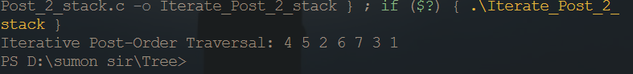
Problem 13
A program to check if a binary tree is BST or not.
#include <stdio.h>
#include <stdlib.h>
#include <limits.h>
struct Node
{
int data;
struct Node *left;
struct Node *right;
};
struct Node *createNode(int data)
{
struct Node *n = (struct Node *)malloc(sizeof(struct Node));
n->data = data;
n->left = NULL;
n->right = NULL;
return n;
}
struct Node *insertNode(struct Node *root, int data)
{
if (root == NULL)
{
return createNode(data);
}
else
{
if (data <= root->data)
{
root->left = insertNode(root->left, data);
}
else
{
root->right = insertNode(root->right, data);
}
return root;
}
}
void inOrder(struct Node *root)
{
if (root != NULL)
{
inOrder(root->left);
printf("%d ", root->data);
inOrder(root->right);
}
}
int isBST(struct Node *root, int min, int max)
{
if (root == NULL)
{
return 1;
}
if (root->data < min || root->data > max)
{
return 0;
}
return isBST(root->left, min, root->data - 1) && isBST(root->right, root->data + 1, max);
}
int main()
{
struct Node *root = NULL;
int val;
printf("Enter the values for the nodes (enter -1 to stop):\n");
while (1)
{
scanf("%d", &val);
if (val == -1)
break;
root = insertNode(root, val);
}
printf("In-Order Traversal: ");
inOrder(root);
printf("\n");
if (isBST(root, INT_MIN, INT_MAX))
{
printf("The binary tree is a Binary Search Tree (BST).\n");
}
else
{
printf("The binary tree is not a Binary Search Tree (BST).\n");
}
return 0;
}
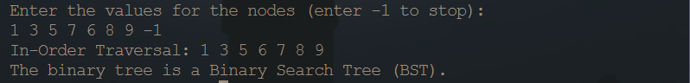
Problem 14
Write an efficient C function to convert a binary tree into its mirror tree
#include <stdio.h>
#include <stdlib.h>
struct Node
{
int data;
struct Node *left;
struct Node *right;
};
struct Node *createNode(int data)
{
struct Node *node = (struct Node *)malloc(sizeof(struct Node));
node->data = data;
node->left = NULL;
node->right = NULL;
return node;
}
void mirrorTree(struct Node *root)
{
if (root == NULL)
return;
struct Node *temp = root->left;
root->left = root->right;
root->right = temp;
mirrorTree(root->left);
mirrorTree(root->right);
}
void inOrderTraversal(struct Node *root)
{
if (root != NULL)
{
inOrderTraversal(root->left);
printf("%d ", root->data);
inOrderTraversal(root->right);
}
}
int main()
{
struct Node *root = createNode(1);
root->left = createNode(2);
root->right = createNode(3);
root->left->left = createNode(4);
root->left->right = createNode(5);
printf("Original Tree (In-Order Traversal): ");
inOrderTraversal(root);
printf("\n");
mirrorTree(root);
printf("Mirror Tree (In-Order Traversal): ");
inOrderTraversal(root);
printf("\n");
return 0;
}
Problem 15
Write a code in-order tree traversal without recursion
#include <stdio.h>
#include <stdlib.h>
struct Node
{
int data;
struct Node *left;
struct Node *right;
};
struct Node *createNode(int data)
{
struct Node *node = (struct Node *)malloc(sizeof(struct Node));
node->data = data;
node->left = NULL;
node->right = NULL;
return node;
}
void morrisInOrderTraversal(struct Node *root)
{
struct Node *current = root;
struct Node *predecessor = NULL;

while (current != NULL)
{
if (current->left == NULL)
{
printf("%d ", current->data);
current = current->right;
}
else
{
predecessor = current->left;
while (predecessor->right != NULL && predecessor->right != current)
{
predecessor = predecessor->right;
}
if (predecessor->right == NULL)
{
predecessor->right = current;
current = current->left;
}
else
{
predecessor->right = NULL;
printf("%d ", current->data);
current = current->right;
}
}
}
}

int main()
{
struct Node *root = createNode(1);
root->left = createNode(2);
root->right = createNode(3);
root->left->left = createNode(4);
root->left->right = createNode(5);
printf("In-Order Traversal: ");
morrisInOrderTraversal(root);
printf("\n");
return 0;
}

Stack Problem
Problem 1
Write a C Program for Introduction to Stack
#include <stdio.h>
#include <stdlib.h>
#define MAX 10
int stack[MAX];
int top = -1;
void push(int value)
{
if (top == MAX - 1)
{
printf(" Stack overflow!\n");
return;
}
stack[++top] = value;
}

int pop()
{
if (top == -1)
{
printf(" Stack underflow!\n");
return -1;
}
return stack[top--];
}
void printStack()
{
if (top == -1)
{
printf(" Stack is empty!\n");
return;
}
printf("Stack contents: ");
for (int i = 0; i <= top; ++i)
{
printf("%d ", stack[i]);
}
printf("\n");
}
int main()
{
int choice, value;
while (1)
{
printf("1. Push\n2. Pop\n3. Print Stack\n4. Exit\n");
printf("Enter your choice: ");
scanf("%d", &choice);
switch (choice)
{
case 1:
printf("Enter value to push: ");
scanf("%d", &value);
push(value);
break;
case 2:
value = pop();
if (value != -1)
{
printf("Popped value: %d\n", value);
}
break;
case 3:
printStack();
break;
case 4:
exit(0);
default:
printf("Invalid choice!\n");
}
}
return 0;
}
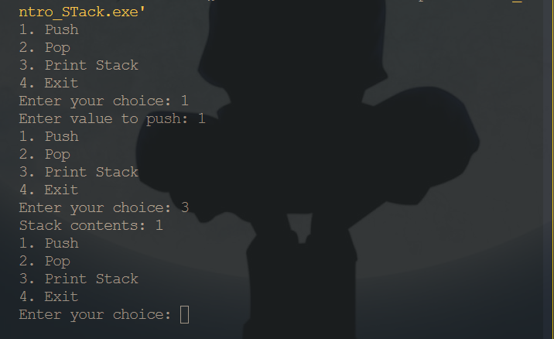
Problem 2
Write a C Program for Infix to Postfix Conversion using Stack
#include <stdio.h>
#include <ctype.h>
#include <string.h>
char stack[20];
int top = -1;
void push(char x)
{
stack[++top] = x;
}
char pop()
{
if (top == -1)
{
return -1;
}
else
{
return stack[top--];
}
}
int priority(char x)
{
if (x == '(')
return 0;
if (x == '+' || x == '-')
return 1;
if (x == '*' || x == '/')
return 2;
return 0;
}
int main()
{
char exp[20];
char *e, x;
printf("Enter your expression: ");
scanf("%s", exp);
e = exp;
printf("Postfix Expression: ");
while (*e != '\0')
{
if (isalnum(*e))
printf("%c", *e);
else if (*e == '(')
push(*e);
else if (*e == ')')
{
while ((x = pop()) != '(')
printf("%c", x);
}
else
{
while (top != -1 && priority(stack[top]) >= priority(*e))
{
printf("%c", pop());
}
push(*e);
}
e++;
}
while (top != -1)
{
printf("%c", pop());
}
printf("\n");
return 0;
}
Problem 3
Write a C Program for Reverse a String using Stack
#include <stdio.h>
#include <stdlib.h>
#include <string.h>
#define MAX 50
char stack[MAX];
int top = -1;
void push(char value) {
if (top == MAX - 1) {
printf("Stack overflow!\n");
return;
}
stack[++top] = value;
}
char pop() {
if (top == -1) {
printf("Stack underflow!\n");
return '\0';
}
return stack[top--];
}
void reverseString(char str[]) {
for (int i = 0; i < strlen(str); i++) {
push(str[i]);
}
for (int i = 0; i < strlen(str); i++) {
str[i] = pop();
}
}
int main() {
char str[MAX];
printf("Enter a string: ");
fgets(str, MAX, stdin);
str[strcspn(str, "\n")] = '\0';
reverseString(str);

printf("Reversed string: %s\n", str);
return 0;
}
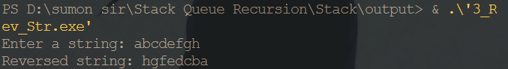
Problem 4
Write a C Program for Implement two stacks in an array
#include <stdio.h>
#include <stdlib.h>
#define MAX 10
int stack[MAX];
int top1 = -1; // Top of the first stack
int top2 = MAX; // Top of the second stack
void push1(int value) {
if (top1 + 1 == top2) {
printf("Stack 1 overflow!\n");
return;
}
stack[++top1] = value;
}
void push2(int value) {
if (top2 - 1 == top1) {
printf("Stack 2 overflow!\n");
return;
}
stack[--top2] = value;
}
int pop1() {
if (top1 == -1) {
printf("Stack 1 underflow!\n");
return -1;
}
return stack[top1--];
}
int pop2() {
if (top2 == MAX) {
printf("Stack 2 underflow!\n");
return -1;
}
return stack[top2++];
}
void printStacks() {
if (top1 == -1) {
printf("Stack 1 is empty!\n");
} else {
printf("Stack 1 contents: ");
for (int i = 0; i <= top1; ++i) {
printf("%d ", stack[i]);
}
printf("\n");
}
if (top2 == MAX) {
printf("Stack 2 is empty!\n");
} else {
printf("Stack 2 contents: ");
for (int i = MAX - 1; i >= top2; --i) {
printf("%d ", stack[i]);
}
printf("\n");
}
}
int main() {
int choice, value;
while (1) {
printf("1. Push into Stack 1\n2. Pop from Stack 1\n");
printf("3. Push into Stack 2\n4. Pop from Stack 2\n5. Print Stacks\n6. Exit\n");
printf("Enter your choice: ");
scanf("%d", &choice);
switch (choice) {
case 1:
printf("Enter value to push into Stack 1: ");
scanf("%d", &value);
push1(value);
break;
case 2:
value = pop1();
if (value != -1) {
printf("Popped value from Stack 1: %d\n", value);
}
break;
case 3:
printf("Enter value to push into Stack 2: ");
scanf("%d", &value);
push2(value);
break;
case 4:
value = pop2();
if (value != -1) {
printf("Popped value from Stack 2: %d\n", value);
}
break;
case 5:
printStacks();
break;
case 6:
exit(0);
default:
printf("Invalid choice!\n");
}
}
return 0;
}
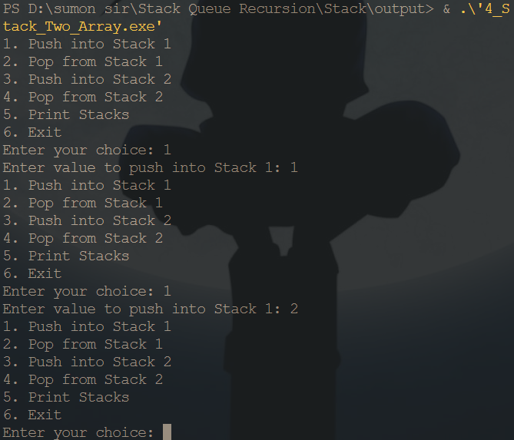
Problem 5
Write a C Program for Check for balanced parentheses in an expression
#include <stdio.h>
#include <stdlib.h>
#define MAX_SIZE 100
typedef struct Stack
{
char data[MAX_SIZE];
int top;
} Stack;
Stack bracketStack;
void initStack(Stack *stack)
{
stack->top = -1;
}

int isEmpty(Stack *stack)
{
return stack->top == -1;
}
void push(Stack *stack, char c)
{
if (stack->top == MAX_SIZE - 1)
{
printf("Stack overflow!\n");
return;
}
stack->top++;
stack->data[stack->top] = c;
}
char pop(Stack *stack)
{
if (isEmpty(stack))
{
printf("Stack underflow!\n");
return 0;
}
char c = stack->data[stack->top];
stack->top--;
return c;
}
int isMatchingPair(char a, char b)
{
return (a == '(' && b == ')') || (a == '{' && b == '}') || (a == '[' && b == ']');
}
int areBracketsBalanced(char *expr)
{
initStack(&bracketStack);
for (int i = 0; i < strlen(expr); i++)
{
if (isEmpty(&bracketStack))
{
push(&bracketStack, expr[i]);
}
else if (isMatchingPair(bracketStack.data[bracketStack.top], expr[i]))
{
pop(&bracketStack);
}
else
{
push(&bracketStack, expr[i]);
}
}
return isEmpty(&bracketStack);
}

int main()
{
printf("Enter the expression: ");
char expr[100];
scanf("%s", expr);
if (areBracketsBalanced(expr))
{
printf("Balanced\n");
}
else
{
printf("Not Balanced\n");
}
return 0;
}
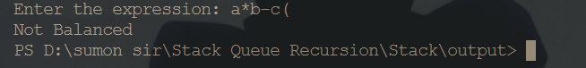
Problem 6
Write a C Program for Reverse a stack using recursion
#include <stdio.h>
#include <stdlib.h>
#define MAX 10
int stack[MAX];
int top = -1;
void push(int value) {
if (top == MAX - 1) {
printf("Stack overflow!\n");
return;
}
stack[++top] = value;
}
int pop() {
if (top == -1) {
printf("Stack underflow!\n");
return -1;
}
return stack[top--];
}
void insertAtBottom(int item) {
if (top == -1) {
push(item);
} else {
int temp = pop();
insertAtBottom(item);

push(temp);
}
}
void reverseStack() {
if (top != -1) {
int item = pop();
reverseStack();
insertAtBottom(item);
}
}

int main() {
int choice, value;
while (1) {
printf("1. Push\n2. Pop\n3. Reverse Stack\n4. Exit\n");
printf("Enter your choice: ");
scanf("%d", &choice);
switch (choice) {
case 1:
printf("Enter value to push: ");
scanf("%d", &value);
push(value);
break;
case 2:
value = pop();
if (value != -1) {
printf("Popped value: %d\n", value);
}
break;
case 3:
reverseStack();
printf("Stack reversed!\n");
break;
case 4:
exit(0);
default:
printf("Invalid choice!\n");
}
}
return 0;
}
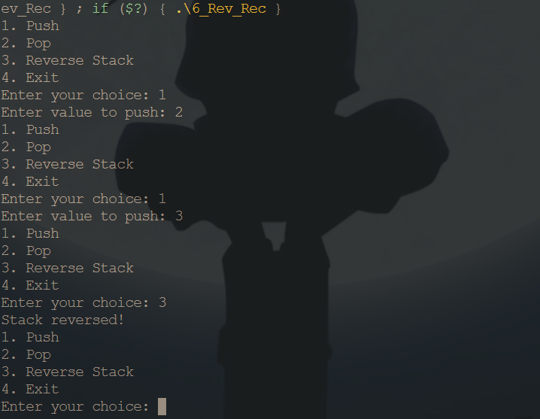

Problem 7
Write a C Program for Implement Stack using Queues
#include <stdio.h>
#include <stdlib.h>
#define MAX 10
struct Queue
{
int front;
int rear;
int items[MAX];
};
struct Stack
{
int top;
int items[MAX];
};
void initQueue(struct Queue *q)
{
q->front = q->rear = 0;
}
void enqueue(struct Queue *q, int value)
{
if (q->rear == MAX - 1)
{
printf(" Queue is full!\n");
return;
}
q->rear++;
q->items[q->rear] = value;
}
int dequeue(struct Queue *q)
{
if (q->front == q->rear)
{
printf(" Queue is empty!\n");
return -1;
}
return q->items[q->front++];
}
void initStack(struct Stack *s)
{
s->top = -1;
}
void push(struct Stack *s, int value)
{
if (s->top == MAX - 1)
{
printf(" Stack overflow!\n");
return;
}
s->top++;
s->items[s->top] = value;
}
int pop(struct Stack *s)
{
if (s->top == -1)
{
printf(" Stack underflow!\n");
return -1;
}
return s->items[s->top--];
}
void printQueue(struct Queue *q)
{
if (q->front == q->rear)
{
printf(" Queue is empty!\n");
return;
} printf("Queue contents: ");
for (int i = q->front + 1; i <= q->rear; ++i)
{
printf("%d ", q->items[i]);
}
printf("\n");
}
void printStack(struct Stack *s)
{
if (s->top == -1)
{
printf(" Stack is empty!\n");
return;
}
printf("Stack contents: ");
for (int i = 0; i <= s->top; ++i)
{
printf("%d ", s->items[i]);
}
printf("\n");
}
int main()
{
struct Queue q;
struct Stack s;
int choice, value;
initQueue(&q);
initStack(&s);
while (1)
{
printf("1. Push\n2. Pop\n3. Print Queue\n4. Print Stack\n5. Exit\n");
printf("Enter your choice: ");
scanf("%d", &choice);
switch (choice)
{
case 1:
printf("Enter value to push: ");
scanf("%d", &value);
enqueue(&q, value);
break;
case 2:
while (q.front != q.rear)
{
value = dequeue(&q);
push(&s, value);
}
value = pop(&s);
if (value != -1)
{
printf("Popped value: %d\n", value);
}
break;
case 3:
printQueue(&q);
break;
case 4:
printStack(&s);
break;
case 5:
exit(0);
default:
printf("Invalid choice!\n");
}
}
return 0;
}
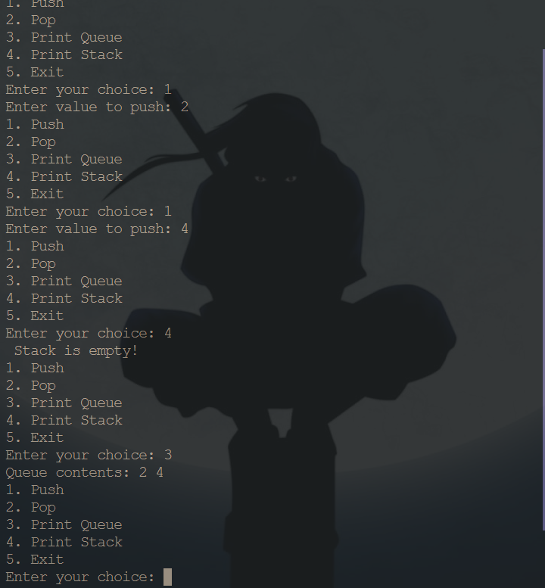

Problem 8
Write a C Program for Design a stack with operations on middle element
#include <stdio.h>
#include <stdlib.h>
#define MAX_SIZE 10
typedef struct Node
{
int data;
struct Node *next;
} Node;
typedef struct Stack
{
Node *head;
int size;
} Stack;
Stack *initializeStack()
{
Stack *stack = (Stack *)malloc(sizeof(Stack));
stack->head = NULL;
stack->size = 0;
return stack;
}
int isEmpty(Stack *stack)
{
return stack->size == 0;
}
int push(Stack *stack, int data)
{
Node *new_node = (Node *)malloc(sizeof(Node));
new_node->data = data;
if (isEmpty(stack))
{
new_node->next = NULL;
}
else
{
new_node->next = stack->head;
}
stack->head = new_node;
stack->size++;
return 1;
}

int pop(Stack *stack)
{
if (isEmpty(stack))
{
return -1;
}
int popped_data = stack->head->data;
Node *temp = stack->head;
stack->head = stack->head->next;
free(temp);
stack->size--;
return popped_data;
}
int getMiddleElement(Stack *stack)
{
if (isEmpty(stack))
{
return -1;
}
Node *fast = stack->head;
Node *slow = stack->head;
while (fast && fast->next)
{
fast = fast->next->next;
slow = slow->next;
}
return slow->data;
}

void printStack(Stack *stack)
{
Node *temp = stack->head;
printf("[");
while (temp)
{
printf("%d, ", temp->data);
temp = temp->next;
}
printf("]\n");
}
int main()
{
Stack *stack = initializeStack();

int choice, value;

while (1)
{
printf("\t1. Push\t2. Pop\t3. Get Middle Element\t4. Print Stack\t5. Exit\n");
printf("Enter your choice: ");
scanf("%d", &choice);
switch (choice)
{
case 1:
printf("Enter value to push: ");
scanf("%d", &value);
if (push(stack, value))
{
printf("%d pushed successfully!\n", value);
}
else
{
printf("Stack overflow!\n");
}
break;
case 2:
value = pop(stack);
if (value != -1)
{
printf("Popped %d from the stack.\n", value);
}
else
{
printf("Stack underflow!\n");
}
break;
case 3:
value = getMiddleElement(stack);
if (value != -1)
{
printf("Middle element: %d\n", value);
}
else
{
printf("Stack is empty!\n");
}
break;
case 4:
if (!isEmpty(stack))
{
printStack(stack);
}
else
{
printf("Stack is empty!\n");
}
break;
case 5:
printf("Exiting...\n");
break;
default:
printf("Invalid choice!\n");
}

if (choice == -1)
{
break;
}
}

return 0;
}
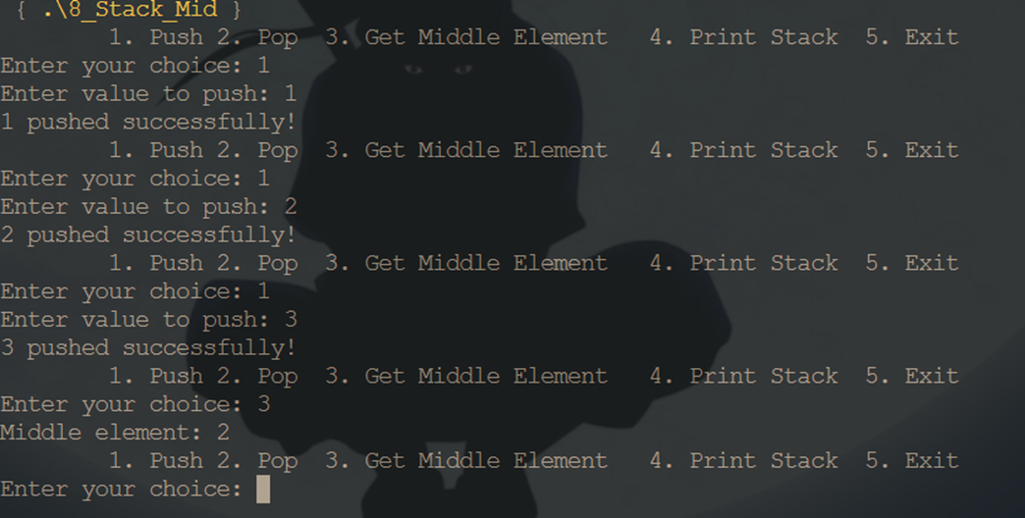
Problem 9
Write a C Program for quick sort using two stack
#include <stdio.h>
#include <stdlib.h>
#define MAX 5
typedef struct StackNode
{
int low;
int high;
} StackNode;
typedef struct Stack
{
int top;
StackNode *arr[MAX];
} Stack;
void push(Stack *stack, int low, int high)
{
if (stack->top == MAX - 1)
{
printf("Stack overflow!\n");
return;
}
stack->arr[++stack->top] = (StackNode *)malloc(sizeof(StackNode));
stack->arr[stack->top]->low = low;
stack->arr[stack->top]->high = high;
}
StackNode *pop(Stack *stack)
{
if (stack->top == -1)
{
return NULL;
}
StackNode *node = stack->arr[stack->top--];
return node;
}
int partition(int arr[], int low, int high)
{
int pivot = arr[high];
int i = (low - 1);

for (int j = low; j < high; j++)
{
if (arr[j] <= pivot)
{
i++;
int temp = arr[i];
arr[i] = arr[j];
arr[j] = temp;
}
}
int temp = arr[i + 1];
arr[i + 1] = arr[high];
arr[high] = temp;

return (i + 1);
}
void quickSortTwoStacks(int arr[], int n)
{
Stack leftStack, rightStack;
leftStack.top = -1;
rightStack.top = -1;
push(&leftStack, 0, n - 1);
while (leftStack.top >= 0)
{
StackNode *left = pop(&leftStack);
int low = left->low;
int high = left->high;
free(left);
int pivotIndex = partition(arr, low, high);
if (pivotIndex - 1 > low)
{
push(&leftStack, low, pivotIndex - 1);
}
if (pivotIndex + 1 < high)
{
push(&rightStack, pivotIndex + 1, high);
}
}
while (rightStack.top >= 0)
{
StackNode *right = pop(&rightStack);
int low = right->low;
int high = right->high;
free(right);
int pivotIndex = partition(arr, low, high);
if (pivotIndex - 1 > low)
{
push(&leftStack, low, pivotIndex - 1);
}
if (pivotIndex + 1 < high)
{
push(&rightStack, pivotIndex + 1, high);
}
}
}
void printArray(int arr[], int n)
{
for (int i = 0; i < n; i++)
{
printf("%d ", arr[i]);
}
printf("\n");
}
int main()
{
int n;
printf("Enter number of elements: ");
scanf("%d", &n);
if (n > MAX)
{
printf("Array size exceeds stack capacity!\n");
return 1;
}
int arr[n];
printf("Enter elements:\n");
for (int i = 0; i < n; i++)
{
scanf("%d", &arr[i]);
}
printf("Unsorted array: ");
printArray(arr, n);
quickSortTwoStacks(arr, n);
printf("Sorted array: ");
printArray(arr, n);
return 0;
} 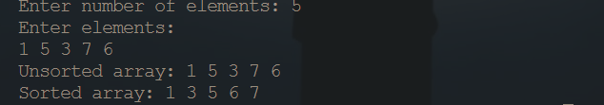

Queue Problem
Prblem 1
Write a C Program for Queue Introduction and Array Implementation
#include <stdio.h>
#include <stdlib.h>
#define MAX_SIZE 10
struct Queue {
int front, rear;
int capacity;
int* array;
};
struct Queue* createQueue(int capacity) {
struct Queue* queue = (struct Queue*)malloc(sizeof(struct Queue));
queue->capacity = capacity;
queue->front = queue->rear = -1;
queue->array = (int*)malloc(queue->capacity * sizeof(int));
return queue;
}
int isEmpty(struct Queue* queue) {
return queue->front == -1;
}
int isFull(struct Queue* queue) {
return (queue->rear + 1) % queue->capacity == queue->front;
}
void enqueue(struct Queue* queue, int item) {
if (isFull(queue)) {
printf("Queue is full. Cannot enqueue %d.\n", item);
return;
}
if (isEmpty(queue)) {
queue->front = queue->rear = 0;
} else {
queue->rear = (queue->rear + 1) % queue->capacity;
}
queue->array[queue->rear] = item;
printf("%d enqueued to the queue.\n", item);
}
int dequeue(struct Queue* queue) {
if (isEmpty(queue)) {
printf("Queue is empty. Cannot dequeue.\n");
return -1; // Return a special value to indicate an error
}
int item = queue->array[queue->front];
if (queue->front == queue->rear) {
queue->front = queue->rear = -1;
} else {
queue->front = (queue->front + 1) % queue->capacity;
}
return item;
}
void display(struct Queue* queue) {
if (isEmpty(queue)) {
printf("Queue is empty.\n");
return;
}
printf("Queue elements: ");
int i = queue->front;
do {
printf("%d ", queue->array[i]);
i = (i + 1) % queue->capacity;
} while (i != (queue->rear + 1) % queue->capacity);
printf("\n");
}
void freeQueue(struct Queue* queue) {
free(queue->array);
free(queue);
}

int main() {
struct Queue* queue = createQueue(MAX_SIZE);
enqueue(queue, 1);
enqueue(queue, 2);
enqueue(queue, 3);
display(queue);
int dequeued = dequeue(queue);
if (dequeued != -1) {
printf("%d dequeued from the queue.\n", dequeued);
}

display(queue);
freeQueue(queue);
return 0;
}
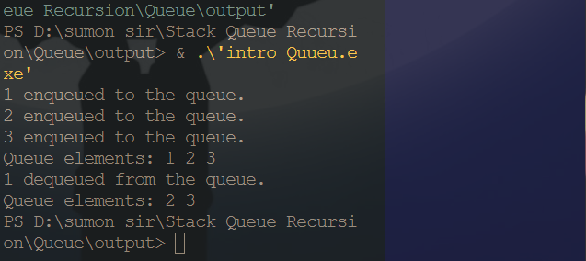
Problem 2
Write a C program to implement the Circular Queue
#include <stdio.h>
#include <stdlib.h>
#define MAX_SIZE 5
struct CircularQueue {
int front, rear;
int capacity;
int* array;
};
struct CircularQueue* createCircularQueue(int capacity) {
struct CircularQueue* queue = (struct CircularQueue*)malloc(sizeof(struct CircularQueue));
queue->capacity = capacity;
queue->front = queue->rear = -1;
queue->array = (int*)malloc(queue->capacity * sizeof(int));
return queue;
}
int isEmpty(struct CircularQueue* queue) {
return queue->front == -1;
}
int isFull(struct CircularQueue* queue) {
return (queue->rear + 1) % queue->capacity == queue->front;
}
void enqueue(struct CircularQueue* queue, int item) {
if (isFull(queue)) {
printf("Queue is full. Cannot enqueue %d.\n", item);
return;
}
if (isEmpty(queue)) {
queue->front = queue->rear = 0;
} else {
queue->rear = (queue->rear + 1) % queue->capacity;
}
queue->array[queue->rear] = item;
printf("%d enqueued to the circular queue.\n", item);
}
int dequeue(struct CircularQueue* queue) {
if (isEmpty(queue)) {
printf("Queue is empty. Cannot dequeue.\n");
return -1; // Return a special value to indicate an error
}
int item = queue->array[queue->front];
if (queue->front == queue->rear) {
queue->front = queue->rear = -1;
} else {
queue->front = (queue->front + 1) % queue->capacity;
}
return item;
}
void display(struct CircularQueue* queue) {
if (isEmpty(queue)) {
printf("Queue is empty.\n");
return;
}
printf("Circular Queue elements: ");
int i = queue->front;
do {
printf("%d ", queue->array[i]);
i = (i + 1) % queue->capacity;
} while (i != (queue->rear + 1) % queue->capacity);
printf("\n");
}
void freeCircularQueue(struct CircularQueue* queue) {
free(queue->array);
free(queue);
}

int main() {
struct CircularQueue* queue = createCircularQueue(MAX_SIZE);
enqueue(queue, 1);
enqueue(queue, 2);
enqueue(queue, 3);
display(queue);
int dequeued = dequeue(queue);
if (dequeued != -1) {
printf("%d dequeued from the circular queue.\n", dequeued);
}
display(queue);
freeCircularQueue(queue);
return 0;
}
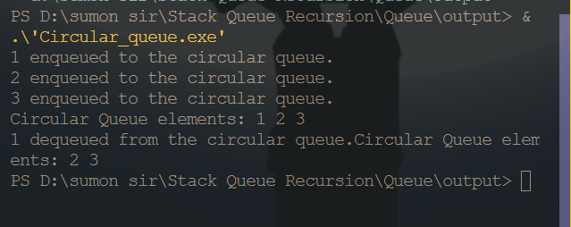
Problem 3
Write a C Program for Linked List Implementation of Queue
#include <stdio.h>
#include <stdlib.h>
struct Node {
int data;
struct Node* next;
};
struct Queue {
struct Node* front;
struct Node* rear;
};
struct Node* createNode(int data) {
struct Node* newNode = (struct Node*)malloc(sizeof(struct Node));
if (newNode == NULL) {
printf("Memory allocation failed.\n");
exit(EXIT_FAILURE);
}
newNode->data = data;
newNode->next = NULL;
return newNode;
}
struct Queue* createQueue() {
struct Queue* queue = (struct Queue*)malloc(sizeof(struct Queue));
if (queue == NULL) {
printf("Memory allocation failed.\n");
exit(EXIT_FAILURE);
}
queue->front = queue->rear = NULL;
return queue;
}
int isEmpty(struct Queue* queue) {
return queue->front == NULL;
}

void enqueue(struct Queue* queue, int item) {
struct Node* newNode = createNode(item);
if (isEmpty(queue)) {
queue->front = queue->rear = newNode;
} else {
queue->rear->next = newNode;
queue->rear = newNode;
}
printf("%d enqueued to the queue.\n", item);
}
int dequeue(struct Queue* queue) {
if (isEmpty(queue)) {
printf("Queue is empty. Cannot dequeue.\n");
exit(EXIT_FAILURE);
}
struct Node* frontNode = queue->front;
int item = frontNode->data;
if (queue->front == queue->rear) {
queue->front = queue->rear = NULL;
} else {
queue->front = frontNode->next;
}
free(frontNode);
return item;
}
void display(struct Queue* queue) {
if (isEmpty(queue)) {
printf("Queue is empty.\n");
return;
}
printf("Queue elements: ");
struct Node* current = queue->front;
while (current != NULL) {
printf("%d ", current->data);
current = current->next;
}
printf("\n");
}
void freeQueue(struct Queue* queue) {
while (!isEmpty(queue)) {
dequeue(queue);
}
free(queue);
}
int main() {
struct Queue* queue = createQueue();
enqueue(queue, 1);
enqueue(queue, 2);
enqueue(queue, 3);
display(queue);
int dequeued = dequeue(queue);
printf("%d dequeued from the queue.\n", dequeued);
display(queue);
freeQueue(queue);
return 0;
}
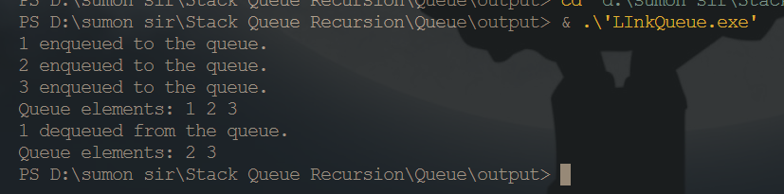
Problem 4
Write a C Program for Implement Queue using Stacks
#include <stdio.h>
#include <stdlib.h>
struct Stack {
int top;
unsigned capacity;
int* array;
};
struct Stack* createStack(unsigned capacity) {
struct Stack* stack = (struct Stack*)malloc(sizeof(struct Stack));
stack->top = -1;
stack->capacity = capacity;
stack->array = (int*)malloc(stack->capacity * sizeof(int));
return stack;
}
int isEmpty(struct Stack* stack) {
return stack->top == -1;
}
int isFull(struct Stack* stack) {
return stack->top == stack->capacity - 1;
}
void push(struct Stack* stack, int item) {
if (isFull(stack)) {
printf("Stack overflow. Cannot push %d.\n", item);
return;
}
stack->array[++stack->top] = item;
}
int pop(struct Stack* stack) {
if (isEmpty(stack)) {
printf("Stack underflow. Cannot pop.\n");
exit(EXIT_FAILURE);
}
return stack->array[stack->top--];
}
struct Stack* stack1;
struct Stack* stack2;
};
struct QueueUsingStacks* createQueue() {
struct QueueUsingStacks* queue = (struct QueueUsingStacks*)malloc(sizeof(struct QueueUsingStacks));
queue->stack1 = createStack(100);
queue->stack2 = createStack(100);
return queue;
}
void enqueue(struct QueueUsingStacks* queue, int item) {
push(queue->stack1, item);
printf("%d enqueued to the queue.\n", item);
}
int dequeue(struct QueueUsingStacks* queue) {
if (isEmpty(queue->stack2)) {
while (!isEmpty(queue->stack1)) {
push(queue->stack2, pop(queue->stack1));
}
}
if (isEmpty(queue->stack2)) {
printf("Queue is empty. Cannot dequeue.\n");
exit(EXIT_FAILURE);
}
return pop(queue->stack2);
}
void display(struct QueueUsingStacks* queue) {
printf("Queue elements: ");
while (!isEmpty(queue->stack2) || !isEmpty(queue->stack1)) {
if (!isEmpty(queue->stack2)) {
printf("%d ", pop(queue->stack2));
} else {
push(queue->stack2, pop(queue->stack1));
}
}
printf("\n");
}
void freeQueue(struct QueueUsingStacks* queue) {
free(queue->stack1->array);
free(queue->stack1);
free(queue->stack2->array);
free(queue->stack2);
free(queue);
}
int main() {
struct QueueUsingStacks* queue = createQueue();
enqueue(queue, 1);
enqueue(queue, 2);
enqueue(queue, 3);
display(queue);
int dequeued = dequeue(queue);
printf("%d dequeued from the queue.\n", dequeued);
display(queue);
freeQueue(queue);
return 0;
}
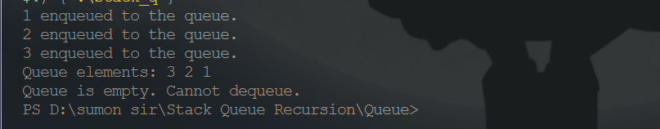
Problem 5
Write a C Program for Check whether a given Binary Tree is Complete or not
#include <stdio.h>
#include <stdlib.h>
struct TreeNode {
int data;
struct TreeNode* left;
struct TreeNode* right;
};
struct TreeNode* createNode(int data) {
struct TreeNode* newNode = (struct TreeNode*)malloc(sizeof(struct TreeNode));
newNode->data = data;
newNode->left = newNode->right = NULL;
return newNode;
}
int isComplete(struct TreeNode* root) {
if (root == NULL) {
return 1; // An empty tree is considered complete
}
struct TreeNode** queue = (struct TreeNode**)malloc(100 * sizeof(struct TreeNode*));
int front = 0, rear = 0;
int flag = 0;
queue[rear++] = root;
while (front < rear) {
struct TreeNode* current = queue[front++];
if (current == NULL) {
flag = 1;
} else {
if (flag) {
free(queue);
return 0;
}
queue[rear++] = current->left;
queue[rear++] = current->right;
}
}
free(queue);
return 1;
}
int main() {
struct TreeNode* root = createNode(1);
root->left = createNode(2);
root->right = createNode(3);
root->left->left = createNode(4);
root->left->right = createNode(5);
root->right->left = createNode(6);
if (isComplete(root)) {
printf("The binary tree is complete.\n");
} else {
printf("The binary tree is not complete.\n");
}
free(root->left->left);
free(root->left->right);
free(root->right->left);
free(root->left);
free(root->right);
free(root);
return 0;
}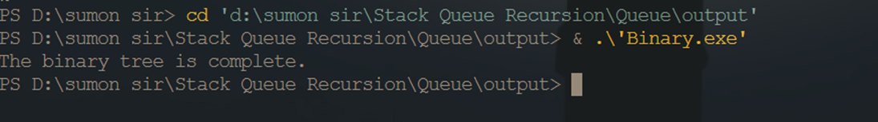

Recursion Problem
Problem 1
Write a program to find out the value of n!
#include <stdio.h>
unsigned long long factorial(int n) {
if (n == 0 || n == 1) {
return 1;
} else {
return n * factorial(n - 1);
}
}
int main() {
int n;
printf("Enter a non-negative integer (n): ");
scanf("%d", &n);
if (n < 0) {
printf("Invalid input. Please enter a non-negative integer.\n");
} else {
printf("%d! = %llu\n", n, factorial(n));
}
return 0;
}
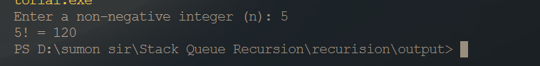
Problem 2
Write a code to implement the Fibonacci sequence algorithm
#include <stdio.h>
void fibonacci(int n) {
int first = 0, second = 1, next, i;
printf("Fibonacci Sequence up to %d terms: ", n);
for (i = 0; i < n; ++i) {
if (i <= 1) {
next = i;
} else {
next = first + second;
first = second;
second = next;
}
printf("%d ", next);
}
printf("\n");
}
int main() {
int n;
printf("Enter the number of terms in the Fibonacci sequence: ");
scanf("%d", &n);
if (n < 0) {
printf("Invalid input. Please enter a non-negative integer.\n");
} else {
fibonacci(n);
}
return 0;
}

